Name: __________ Class: ___ Date: ________

Solution sheet task 1

Tachometer, odometer and taxi meter
The distance travelled per impulse must first be determined based on the tire circumference, encoder signals and gear ratio for the tachometer and odometer. This is not a difficult calculation, but an exercise in converting units. The speed information for the following suggested solutions is provided in m/h, but it can also be converted to km/h.

Programming tasks

Configuring the actuators (only the encoder motor is required in this task):
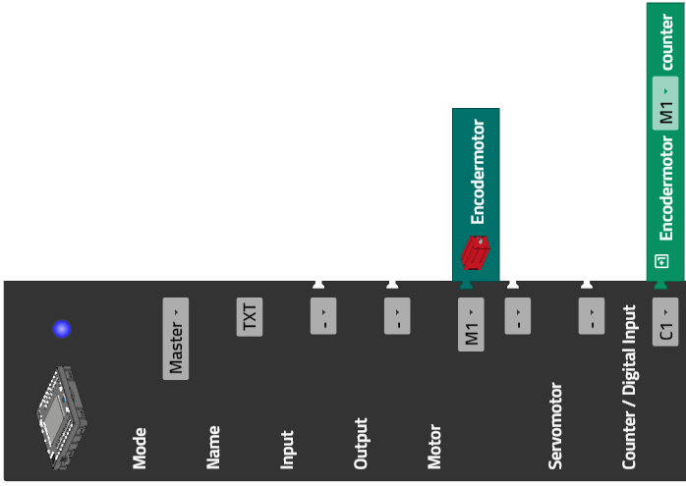

1. Displaying the encoder values
Display configuration:

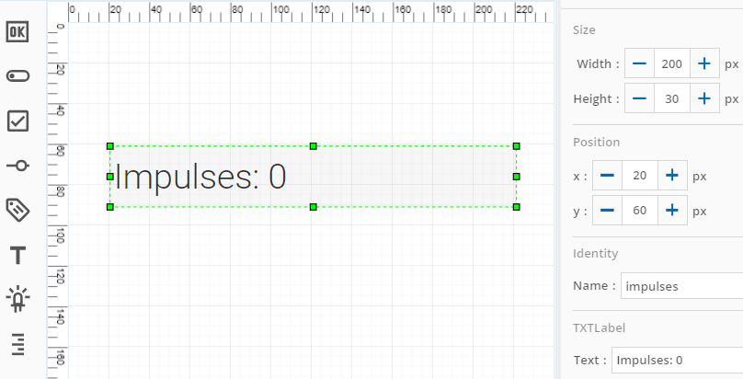

Program (example) to display the counter values for the encoder:
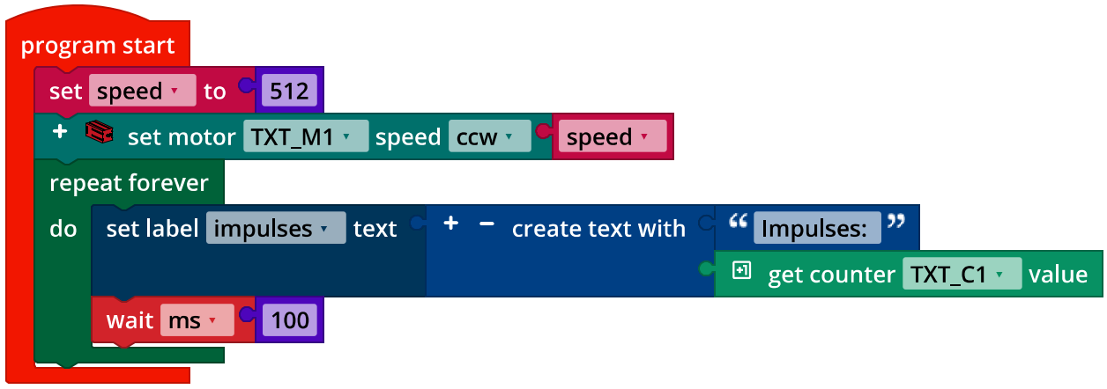
Display_Counter_Encoder.ft

The pause in the loop ensures a controlled and continuous display. If it is left out, the controller will try to compensate for the delay through what is shown on the display.

2. Odometer
The magnetic encoder of the motor delivers 63.9 impulses per revolution of the drive axle. The gear of the differential cage causes the vehicle to gear down by a gear ratio of 14:26 = 7:13.
2a. The circumference of the tire is approx. 20.5 cm (see task 6 from the Robotics TXT 4.0 Base Set; recommended measurement method: place the edge of a piece of paper around the tire, mark the circumference, and then measure the edge to the marking).
The impulses counted over a distance travelled $i$ can be used to calculate the distance $d$ (in m) based on the following formula:
$$d=i·\frac{1}{63.9}·\frac{7}{13}·20.5·\frac{1}{100} m≈i· 0.00172746 m$$

2b. Simple test program to check the measurement:
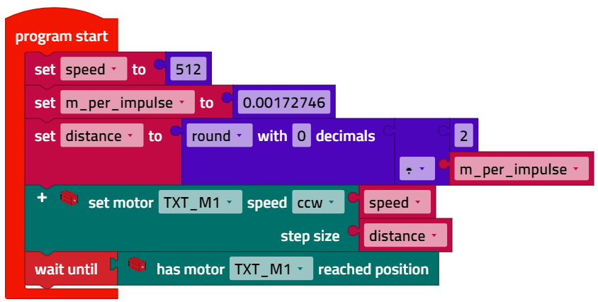
Distance_Test.ft

In tests, the vehicle stops a short distance before reaching the 2m mark. The conversion factor was therefore corrected to 0.0017.

2c. Display configuration:

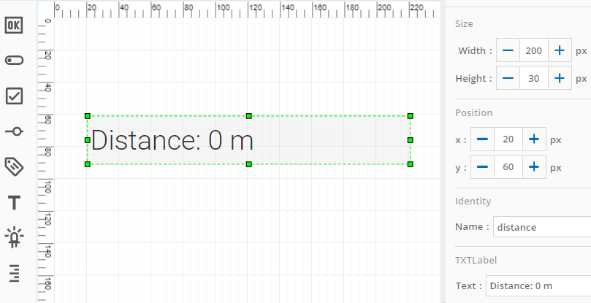

Program (example) odometer:
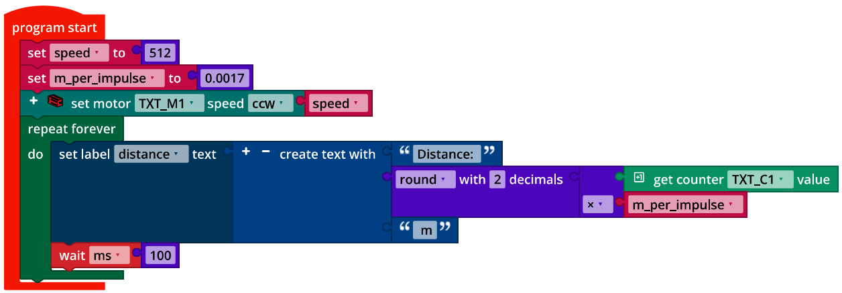
Odometer.ft

2d. The maximum measurable distance travelled $d_{max}$ is
$$d_{max}=65,535∙0.0017 m≈111.41 m$$

3. Tachometer
1 s can be used, for instance, as a fixed interval to determine speed: this is long enough for a precise measurement, and short enough to react quickly to changes in speed.
3a. Therefore, the speed $v$ can be calculated from the impulses counted within a second $i$ as follows:
$$v=i·\frac{1}{63.9}·\frac{7}{13}·20.5·36 m/h≈i·6.2189 m/h$$
If we take the corrected value from programming task 2 into account, then we have:
$$v=i·0.0017·3600 m/h≈i·6.12 m/h$$

3b. Display configuration:

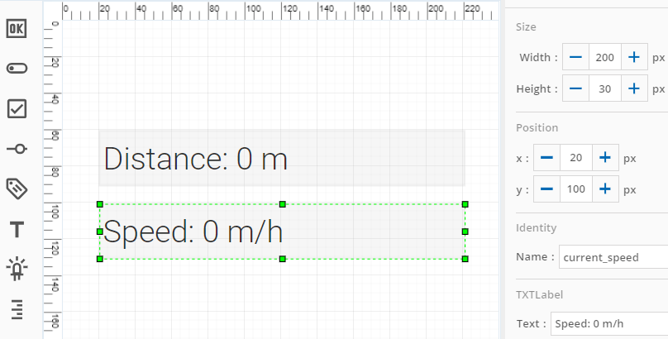

Program (example) tachometer:
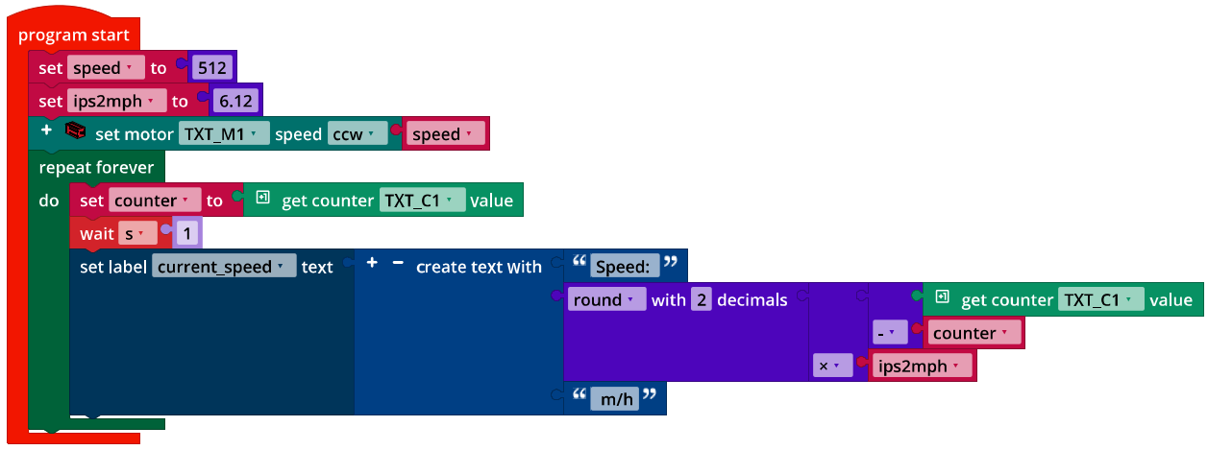
Tachometer.ft

Program (example) odometer and tachometer:
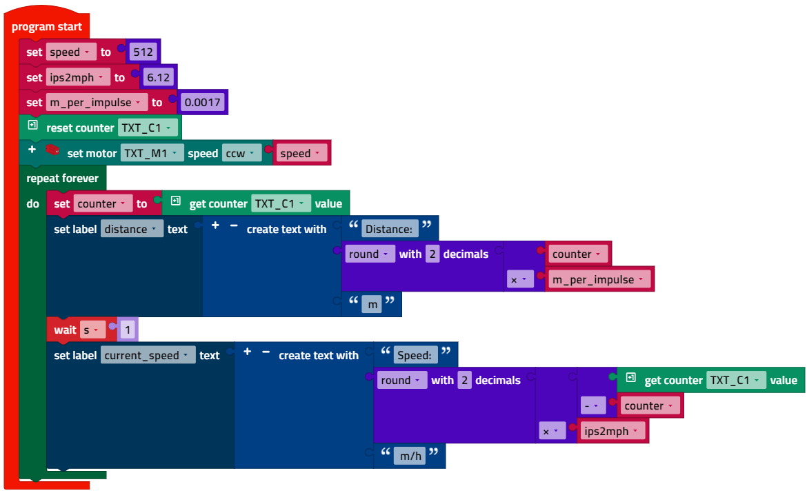
Tachometer_and_Odometer.ft

Experimental tasks

1. Tachometer and odometer concurrent
Program (example):
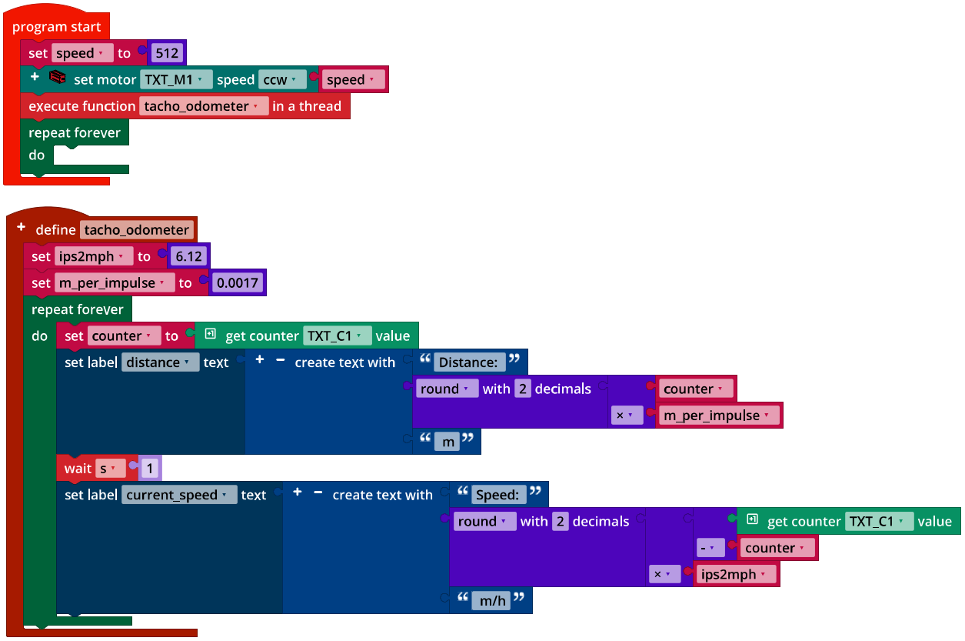
Tachometer_and_Odometer_Thread.ft

2. Taxi meter
2a. Since the scale of the vehicle model to a real vehicle is around 1:10, it is a good idea to indicate the price for a distance of 100m for the taxi meter, for instance 2 €/100 m, with a 3.50 € base fee.
2b. State diagram:

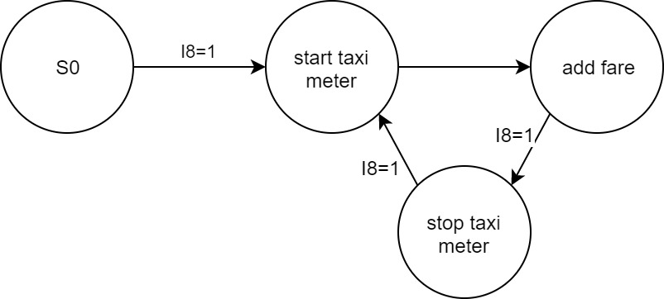
State-Transition_Diagram_Taxi_Meter.drawio

2c. Display configuration:

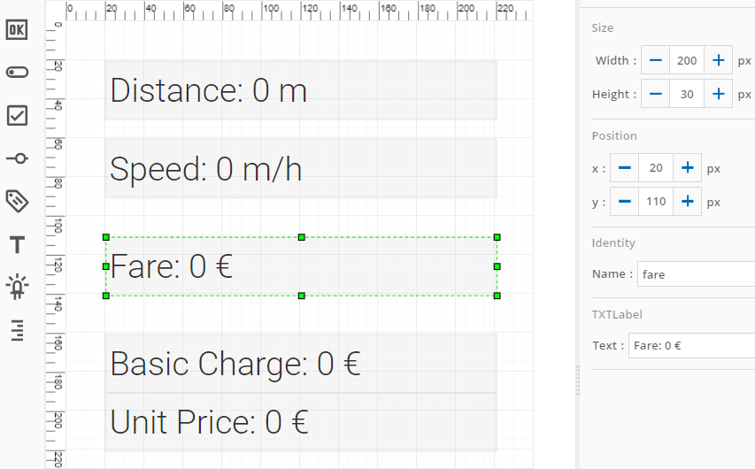

The encoder impulses are only counted up to 65,535. Therefore, the trip price should be added up regularly, for instance every five seconds.

Program excerpt (example) taximeter:
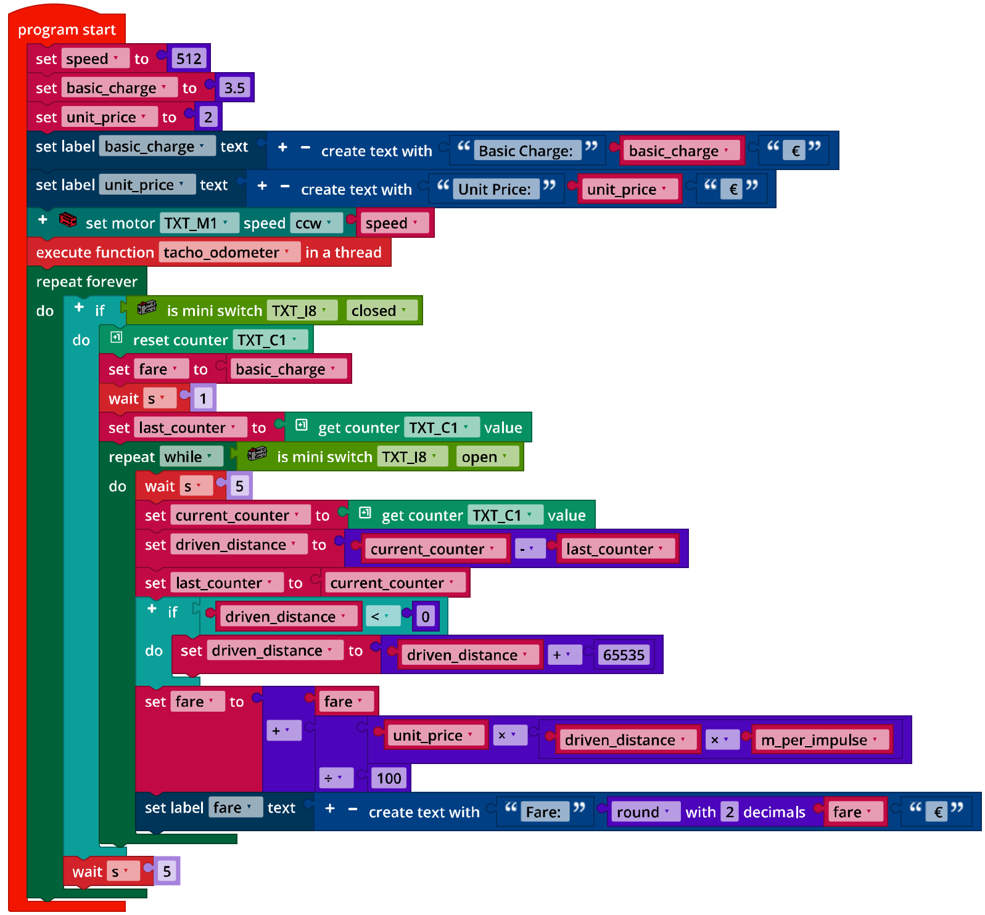
Taxi_Meter.ft

You can also move the taxi meter to a concurrent process (thread). It will then simply run alongside the tachometer and odometer while vehicle navigation is handled in the main program.
Annex

Task 1: Cruise control, odometer and taxi meter

Required materials
- PC for program development, local or via web interface.
- USB cable or BLE or WiFi connection to transmit the program to the TXT4.0.
- Tape measure or ruler, paper strips (to measure the tire circumference).

Further information
[1] Andreas Wolf: Tachometer. Die Geschichte eines unverzichtbaren Instruments. 04.08.2014.
[2] Alper Aribal (SeoRocket): Taxameter. DeWiki.de.
[3] Online diagram editor for creating state diagrams (Format drawio): https://www.diagrammeditor.de/

