Name: __________ Class: ___ Date: ________

Task 1

Tachometer, odometer and taxi meter
The vehicle is built and equipped with a cruise control (speed display) and odometer. You can also equip it with a taximeter.

Construction task
Build the vehicle according to the building instructions. First, connect only the motor (M1) and the encoder (C1 and 9V voltage output) to the TXT (see wiring diagram). In this task, the vehicle will be equipped with a cruise control (to display the speed), an odometer, and a taximeter.

Please note: Do not attach the servo lever at first; the next task will deal with driving straight ahead. It is simpler to install the red servo tab the wrong way around to lock the steering:
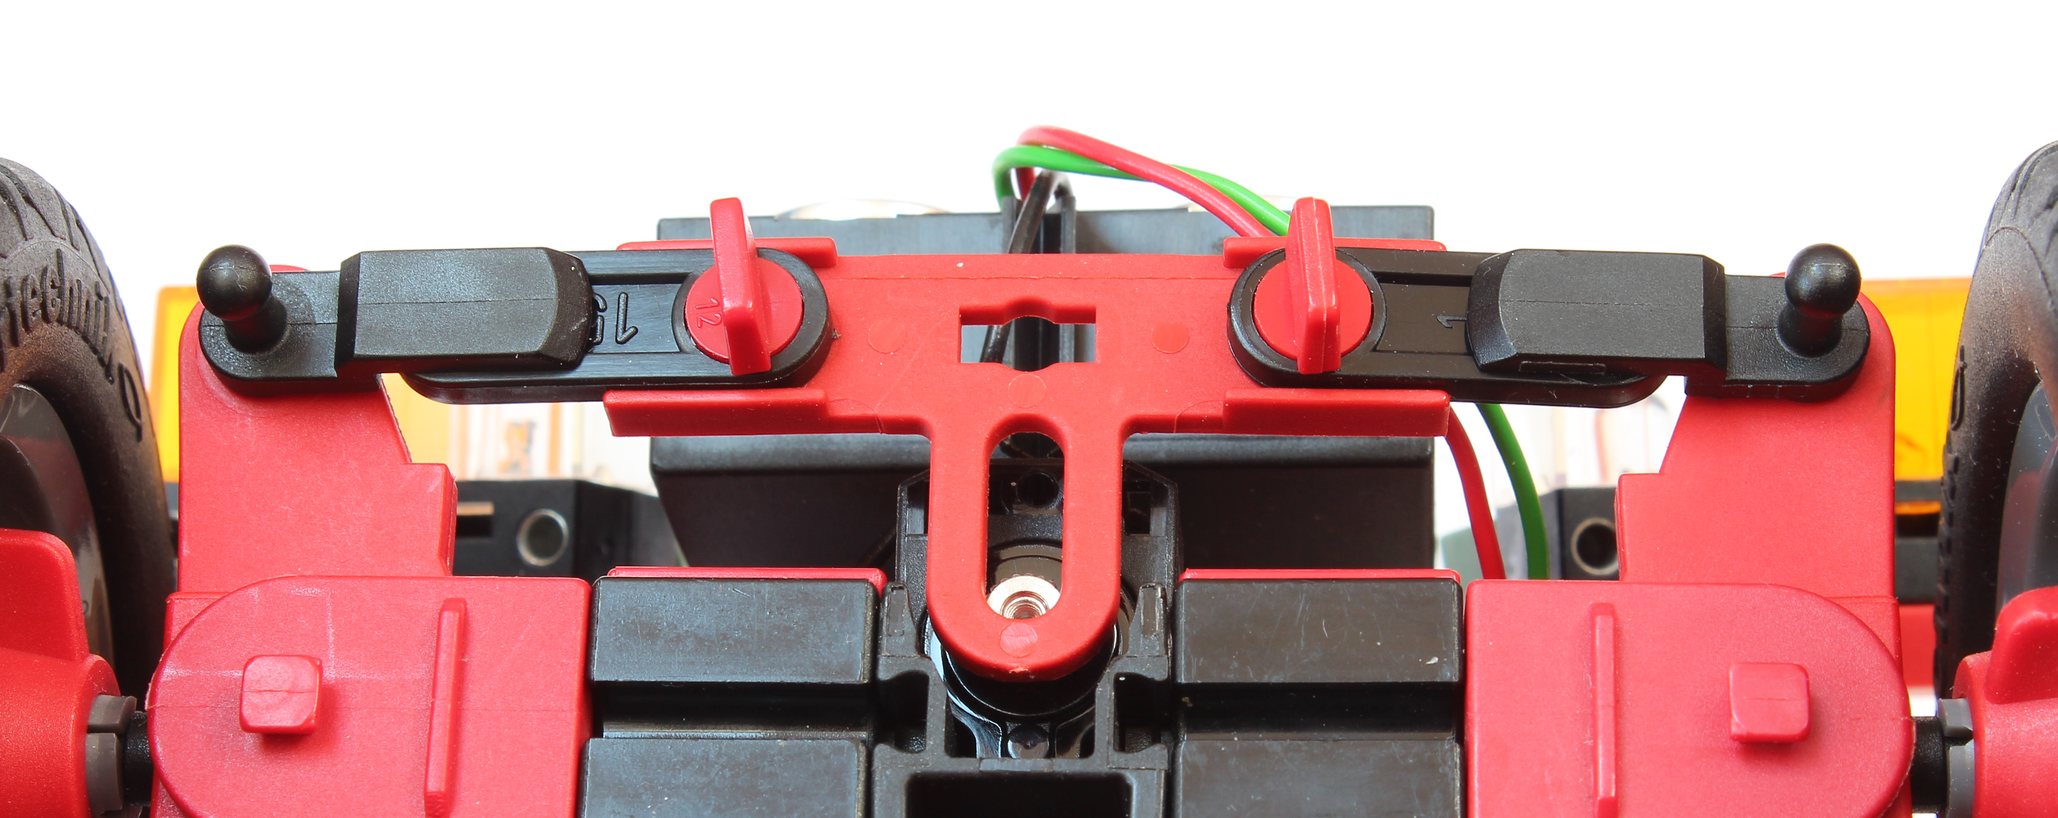
Montage Servo-Lasche.jpg
Tip: To test your program, it is a good idea to first put the vehicle up on blocks, meaning you should put something under the vehicle or the rear bumper so that the rear wheels do not touch the ground.

Programming tasks

1. Displaying the encoder values
First, write a program that starts the motor and then continuously shows the impulses of the encoder (C1) since the start on the display of the TXT.

2. Odometer
You should now calculate the distance travelled by the vehicle in meters based on the impulses of the encoder, then show this on the display of the TXT (odometer).
2a. To do so, you must first determine the gearing ratio and measure the circumference of the tires (see also task 6 from the Robotics TXT 4.0 Base Set). What values do you determine? Indicate a formula for converting the encoder impulses into the distance travelled (in meters).
2b. Write a simple test program with which you can check the precision of the measurement along a test track, for instance of 2 m in length. Correct the conversion factor if necessary.
2c. Adjust your Blockly program from programming task 1 and the display output so that the distance travelled is displayed.
2d. The counter input can have a maximum value of 65.535. How long, then, is the maximum travel distance (in meters) your odometer can measure?

3. Tachometer
In addition to the distance travelled, the vehicle's current speed should be shown on the display of the TXT (speed control).
3a. To determine the speed, you must calculate the distance travelled in a certain time unit (for instance in a second). Provide a formula for calculating speed.
3b. Add the speed calculation to your Blockly program from programming task 2, and show the current speed on the display of the TXT beside the distance travelled.

Experimental tasks

1. Tachometer and odometer concurrent
The display of the distance travelled and speed should now be handled in a concurrent program (thread) in parallel to the vehicle's actual control program.
Convert the program so that the display runs in parallel to the main program and so that it is updated continuously. The motor should be started in the main program.

2. Taxi meter
The autonomous vehicle will now be equipped with a taxi meter, so that it can be used later as a taxi. Install a button on your vehicle and connect it to I8.
The taxi meter should start when the button is pressed the first time, and the trip price should be shown on the display of the TXT. When the button is pressed a second time, the taxi meter should stop and the price to be paid should be displayed.
2a. The price is composed of a base fee and a rate based on the distance travelled. Define the base fee and rate in a variable.
2b. Draw a state diagram for the taxi meter.
2c. Add this function to your Blockly program accordingly. The base fee and rate should also be shown on the display.

Annex

Task 1: Tachometer, odometer and taxi meter

Required materials
- PC for program development, local or via web interface.
- USB cable or BLE or WiFi connection to transmit the program to the TXT4.0.
- Tape measure or ruler, paper strips (to measure the tire circumference).

Further information
[1] Andreas Wolf: Tachometer. Die Geschichte eines unverzichtbaren Instruments. 04.08.2014.
[2] Alper Aribal (SeoRocket): Taxameter. DeWiki.de.

