Name: __________ Class: ___ Date: ________

Solution sheet task 2

Brake assistant, cruise control and lane departure warning system
Students should make active use of outputting variables on the console during programming, and complete tests first with their vehicle on blocks (or without the rear wheels mounted). The “live” tests can then be completed with track sections put together to create a course. The tracks are available as a PDF file for download in order to print out additional track sections.

Programming tasks
Configuring the actuators and sensors:
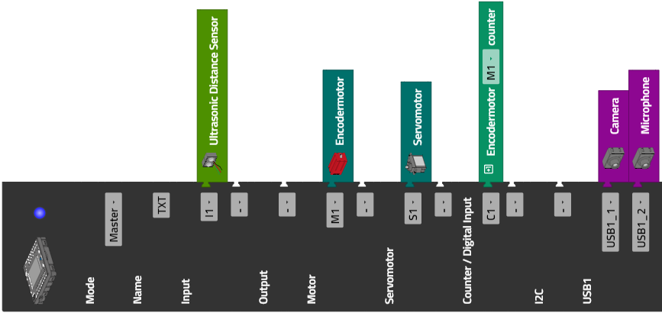

1. Emergency stop
Program excerpt (example): Vehicle completes an emergency stop when it hears a loud noise (such as clapping); output the volume on the console:
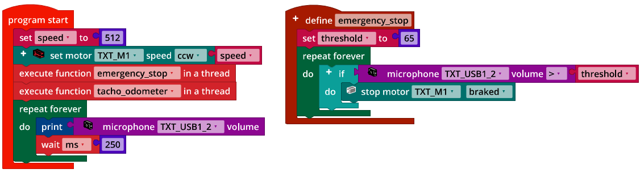
Emergency_Stop.ft

2. Forward travel
The servo setting for travelling straight ahead differs from model to model. It may be necessary to check the value and adjust occasionally. In the following example program for the (experimental) test of forward travel, it is specified in the “straightforward” variables.
Program (example):
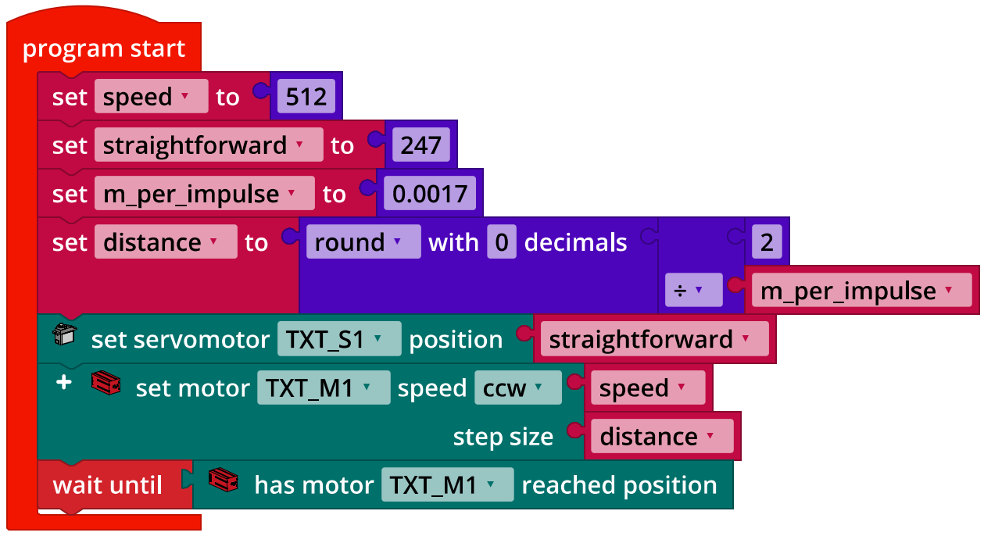
Servo_Calibration.ft

3. Braking assistant
The threshold for the distance from which the braking process should be initiated must be more than 10 cm for the vehicle to brake quickly enough (reaction time of the ultrasound measurement, braking distance). You can simulate the braking distance by stopping the motor in “coasting” mode.
To determine the appropriate distance threshold value for starting the braking process, make the vehicle drive up to a standing obstacle at maximum speed, then stop. You should then adjust the threshold value until the vehicle stops 10 cm in front of the obstacle.

Program excerpt (example) braking assistant:
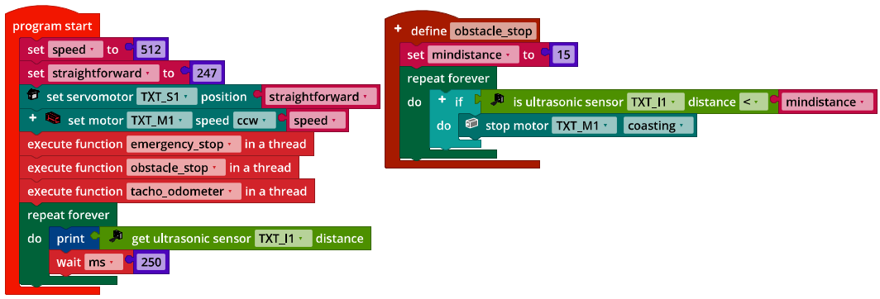
Brake_Assist.ft

4. Speed control
4a. Control circuit of the speed control:
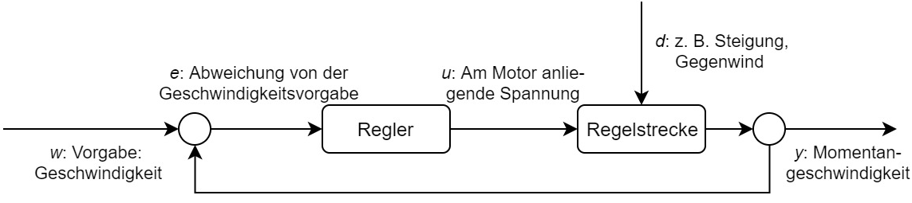
Controlled system
Controller
d: e.g. slope, headwind
y: Current speed
u: Voltage applied to the motor
e: Deviation from the specified speed
w: Specification: Speed
Regelkreis_Tempomat.drawio

The speed control keeps the speed constant even on a slope or in case of other resistant factors interfering with travel. You can clearly demonstrate this with the vehicle on blocks by using your hand to brake the tires.

4b. Program excerpt (example) speed control:
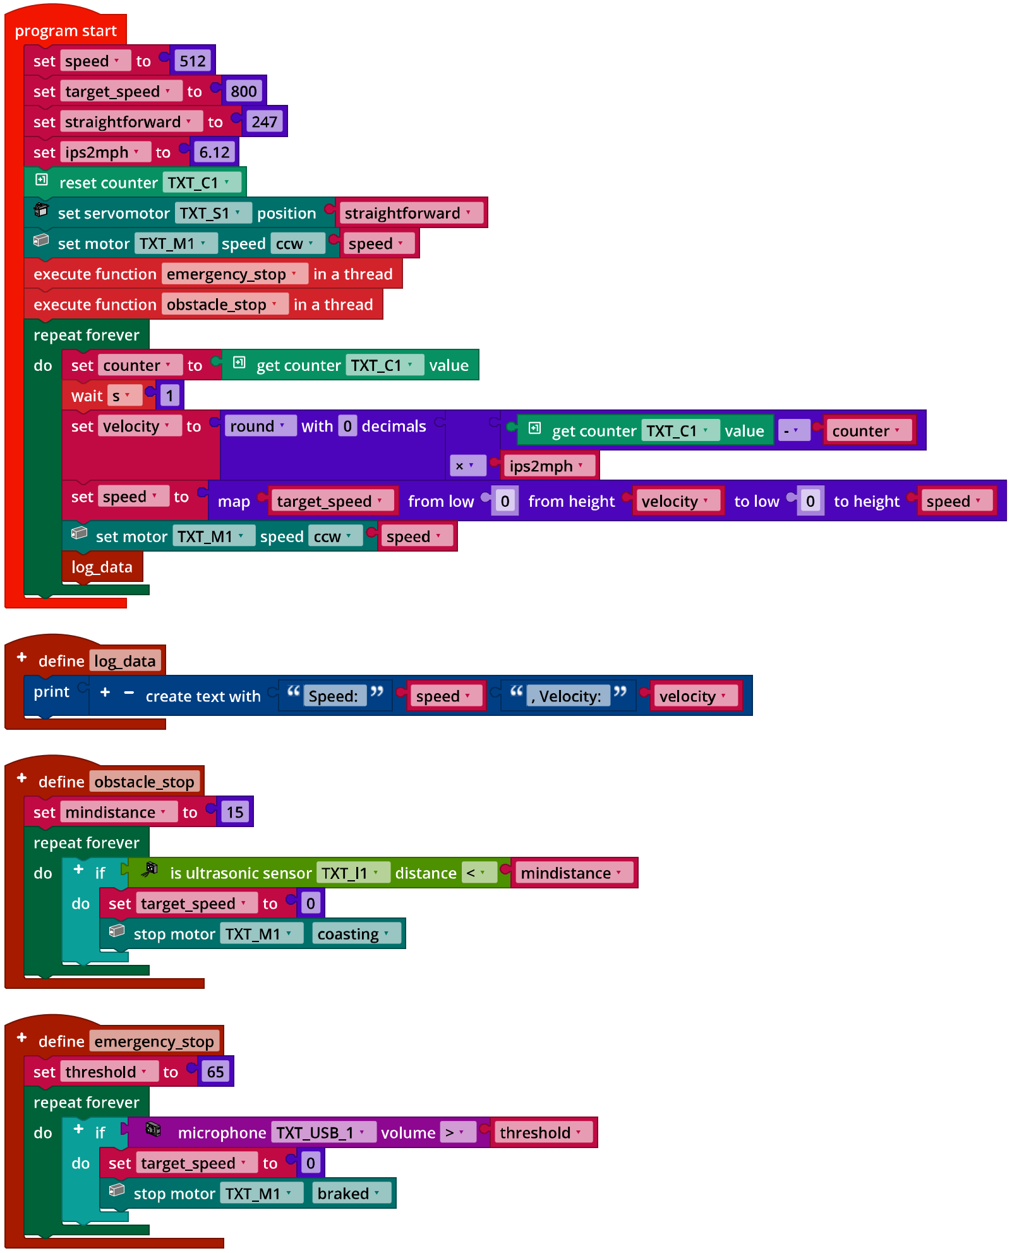
Speed_Control.ft

Experimental tasks

1. Lane departure warning with P controller
Configuring the camera (line detection):
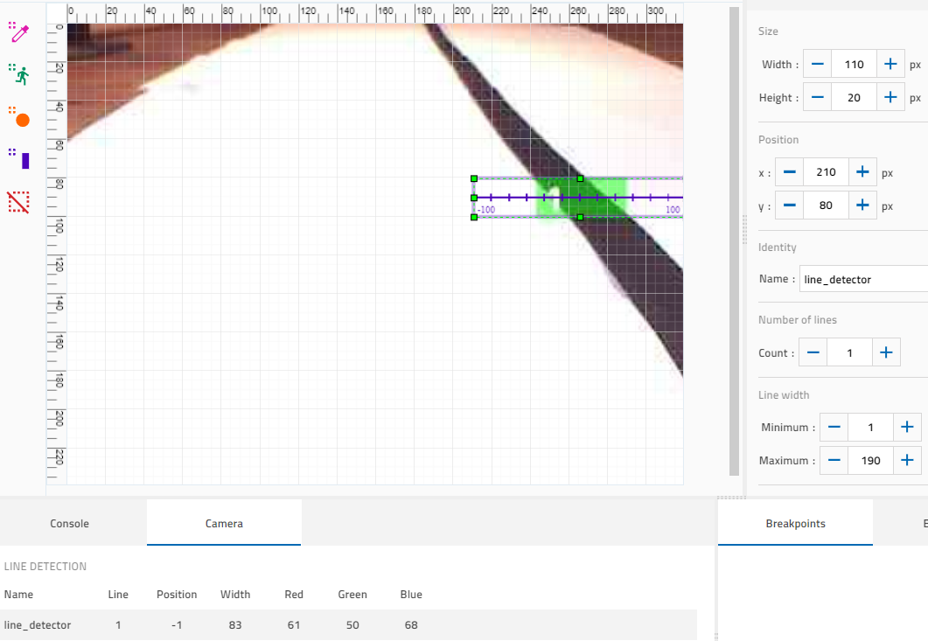

1a. Control circuit for the lane departure warning assistant:
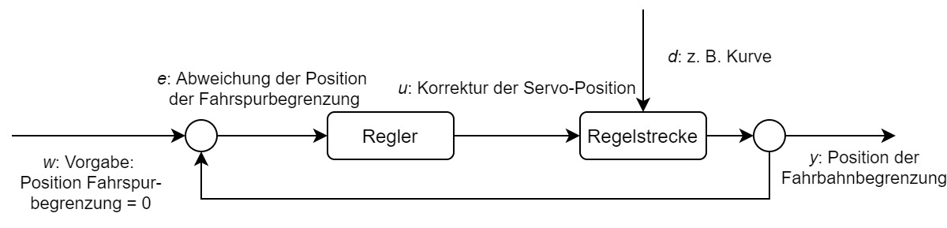
Controlled system
Controller
u: Correction of the servo position
e: Deviation in the position of the track boundary
w: Specification: Position of the track boundary = 0
y: Position of the track boundary
d: e.g. curve
Regelkreis_Spurhalteassistent.drawio

1b. Program (example) lane departure warning with P controller:
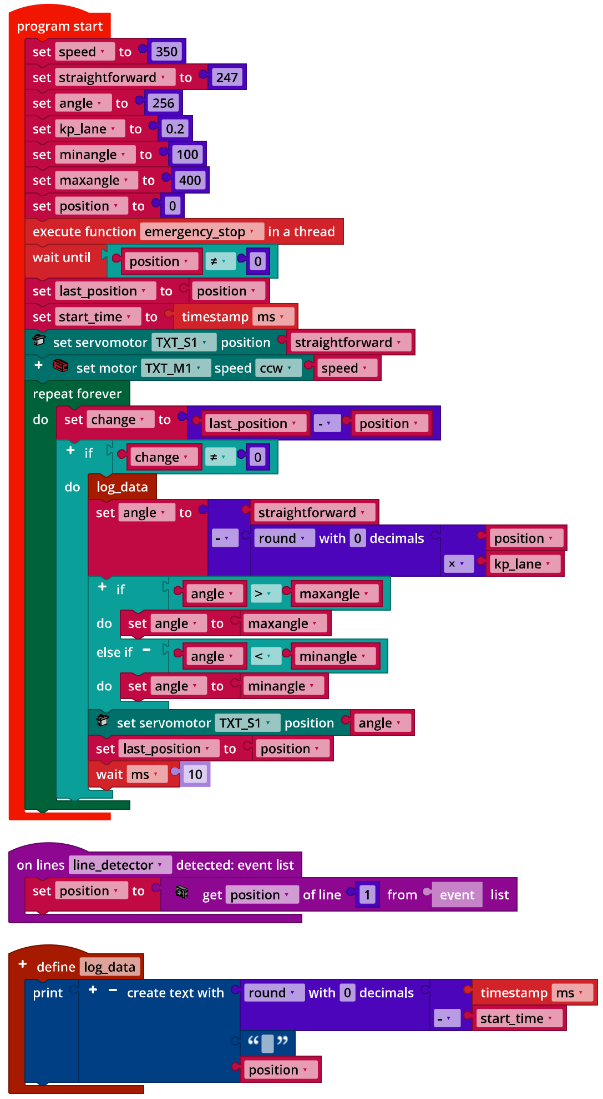
Lane_Keeping_Assist_P-Control.ft
1c. Measurement results for the P controller at a speed of 350 (with $k_{p}∊\{0.1, 0.15, 0.2, 0.25, 0.3, 0.35\})$:

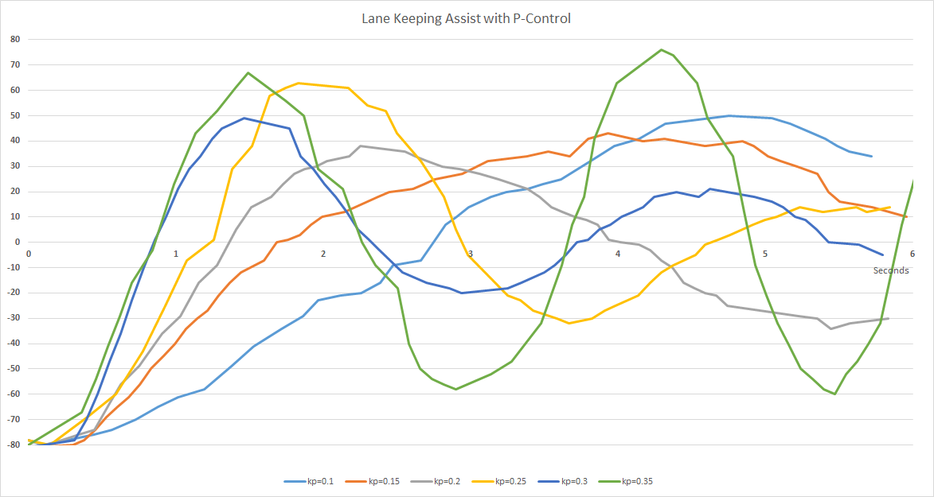
Lane_Keeping_Assist_P-Control_Results.jpg

The maximum refresh rate is 15 fps (frames per second), meaning that the line detection can complete a new position determination at most around every 66.7 ms.

At a value of $k_{p}=0.35$, the controller starts to oscillate in the example solution. At $k_{p}=0.3$, the controller oscillates very quickly with reducing amplitude. The students’ measured results may vary depending on the model (friction, motor power, ...) and program.

2. Lane departure warning with PD controller
2a. Program (example):
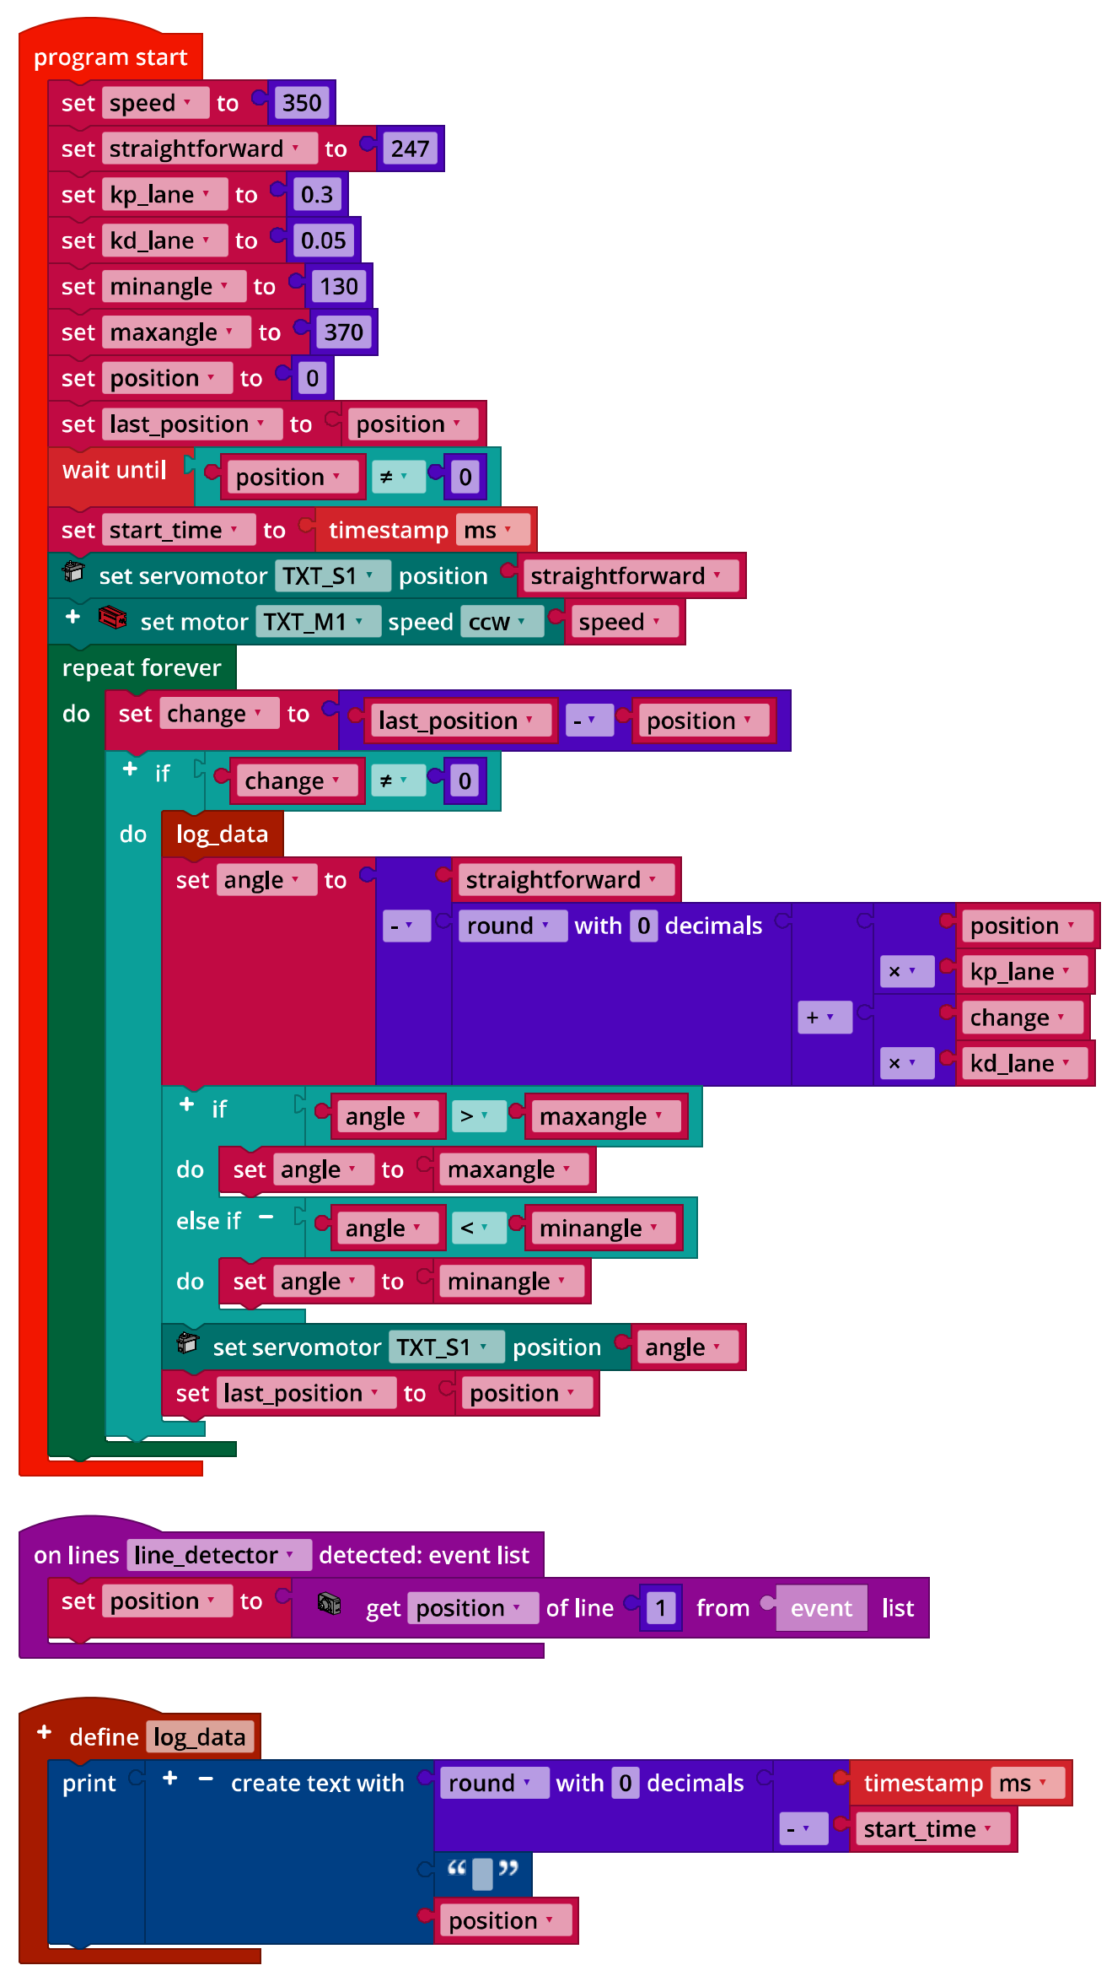
Lane_Keeping_Assist_PD-Control.ft
2b. Measurement results for the PD controller at a speed of 350 and with $k_{p}=0.3$ (for $k_{d}∊\{0.01, 0.02, 0.03, 0.04, 0.05, 0.06, 0.07\})$:
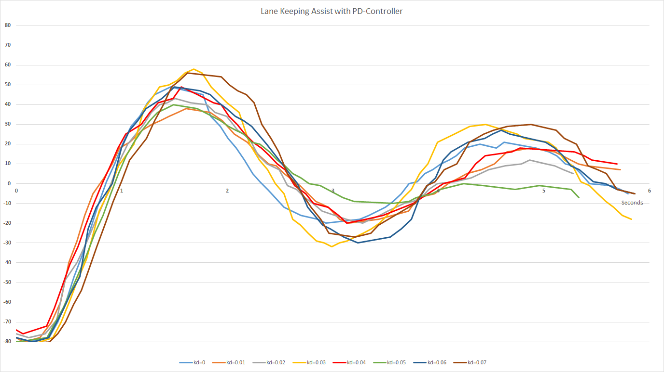
Lane_Keeping_Assist_PD-Control_Results.jpg

The greatest dampening is achieved in the example program with a differential factor of $k_{d}=0.05$ (green line on the image). Here as well, the students’ measured results may vary; however, the measurement processes should be very similar from a qualitative standpoint.

Annex

Task 2: Brake assistant, cruise control and lane departure warning system

Required materials
- PC for program development, local or via web interface.
- USB cable or BLE or WiFi connection to transmit the program to the TXT4.0.
- Travel route with markings on the enclosed sheet (or as a print out of the travel route file)
- Obstacle (such as a book or a box)

Further information
[1] Jim Meininghaus: Die Geschichte des Tempomaten. Wie ein Blinder das Autofahren veränderte. 03.03.2014, motor-talk.de.
[2] Thomas Paulsen: Autonomes Fahren: Die 5 Stufen zum selbstfahrenden Auto. 07.11.2018, adac.de.
[3] Online diagram editor for creating state diagrams (Format drawio): https://www.diagrammeditor.de/

