Name: __________ Class: ___ Date: ________

Solution sheet task 1:

Weather station
Tasks 1 and 2 turn the sensor station into a local weather station. In the experimental tasks, the weather station is connected to a web server via MQTT that displays the measured data and transmitted images in a dashboard.

Construction task
See building instructions.

Programming tasks
Configuring the sensors and actuators:
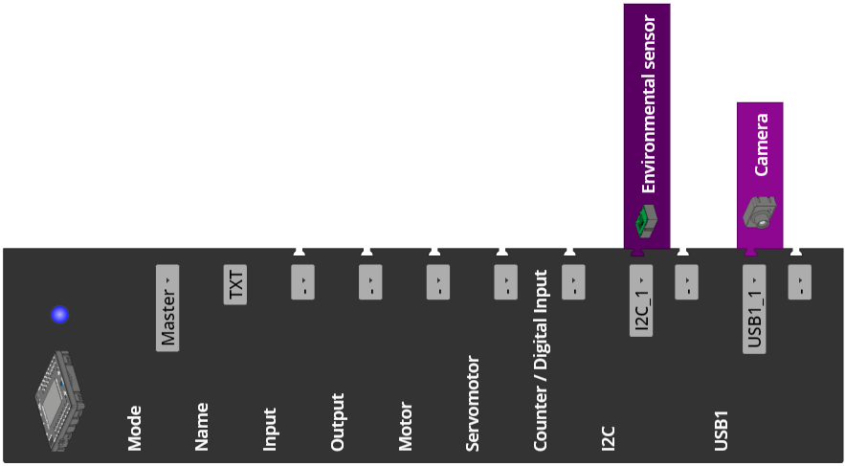

1. Measuring humidity, temperature, and air pressure
1a. Display configuration (example):
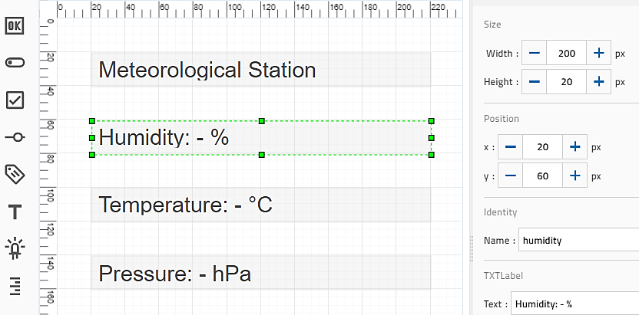
Configuring the display output
1b. Program (example):
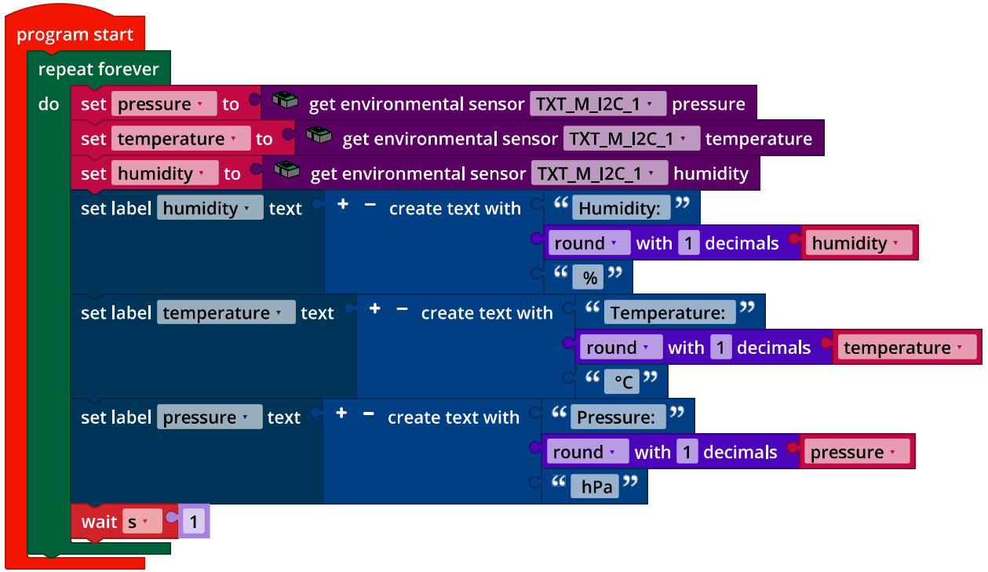
IoT_Meteorological_Station.ft
2. Barometer
2a. Expanding the display configuration (example):
Expanding the display output
2b: Program (example):
The temperature values must be converted into Kelvin before the calculation: 0°C = 273.15 K.
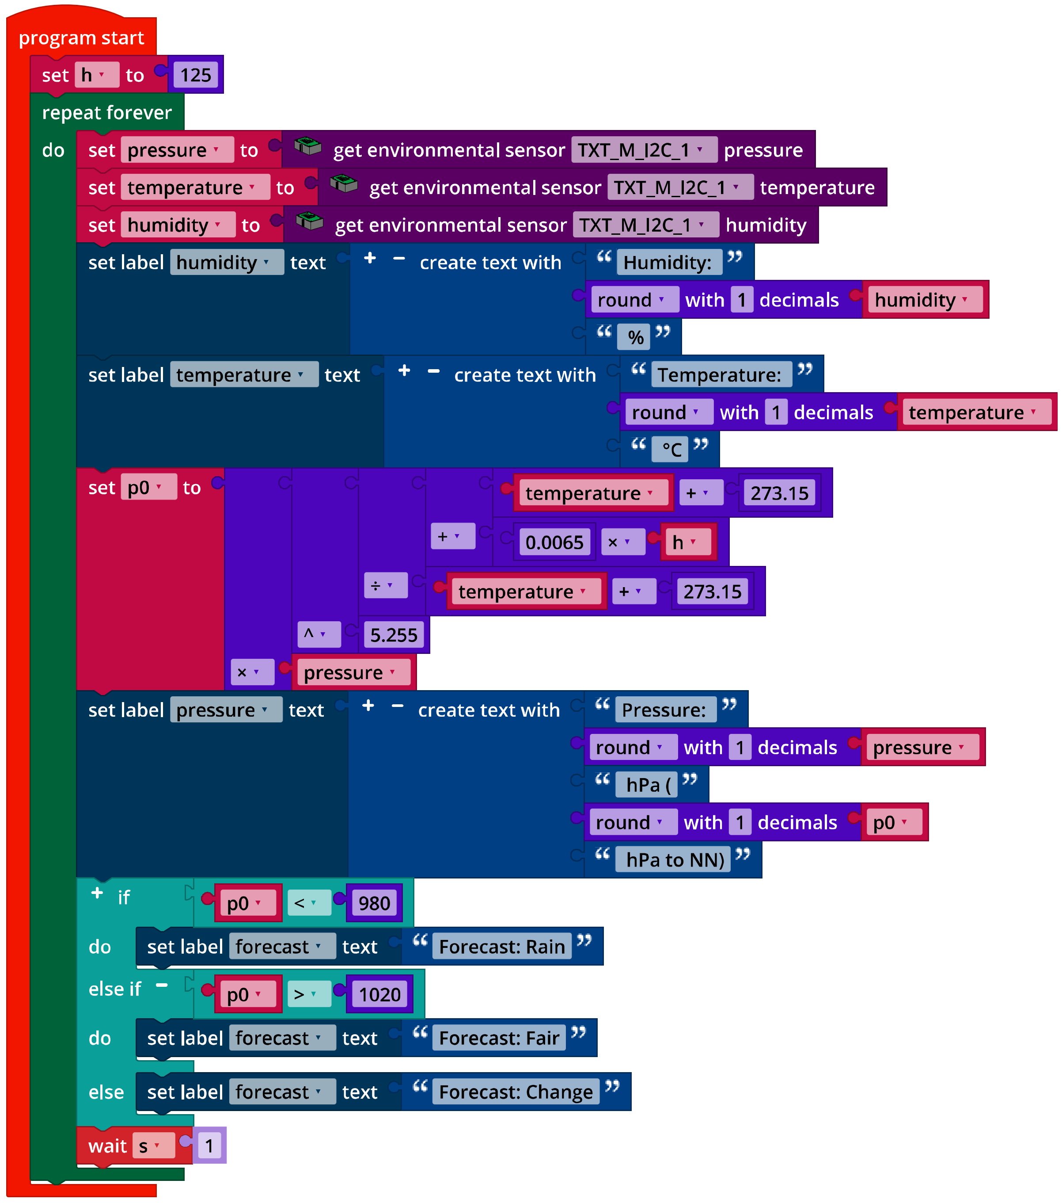
IoT_Barometer.ft

Experimental tasks

1. Determining temperature using the NTC resistor
1a. The resistance of the thermistor and the associated measured temperature values for the environmental sensor can easily be determined via a Log output on the console (see example program below).
Three measured values can be used to determine the coefficients a, b, and c of the Steinhart-Hart equation [4, 5] (T: Temperature in Kelvins, R: NTC resistance in Ohms):
$$\frac{1}{T}=a+b∙\ln\left(R\right)+c∙{ln⁡(R)}^{3}$$
Resistance value | Temperature
1500 Ω | 25.0 °C
2362 Ω | 13.7 °C
2530 Ω | 11.8 °C
Example measurement
The measured values are dependent on the NTC resistance and may deviate.
Coefficients: a = 0.004535418128, b = -0.0003767491105, c = 0.000004023802790

1b. Expanding the display:
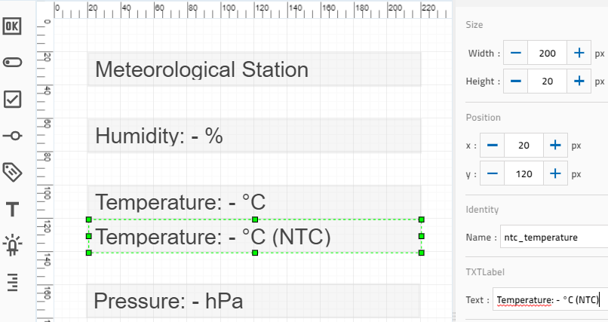
Configuring the display output of NTC temperature measurement
1c. Expanding the program (example):
Calculating the temperature value based on the NTC resistance and output of the measured values for the NTC resistor and temperature sensor on the console.
Here as well, the temperature value calculated from the thermistor must then be converted into Kelvins: 0°C = 273.15 K.

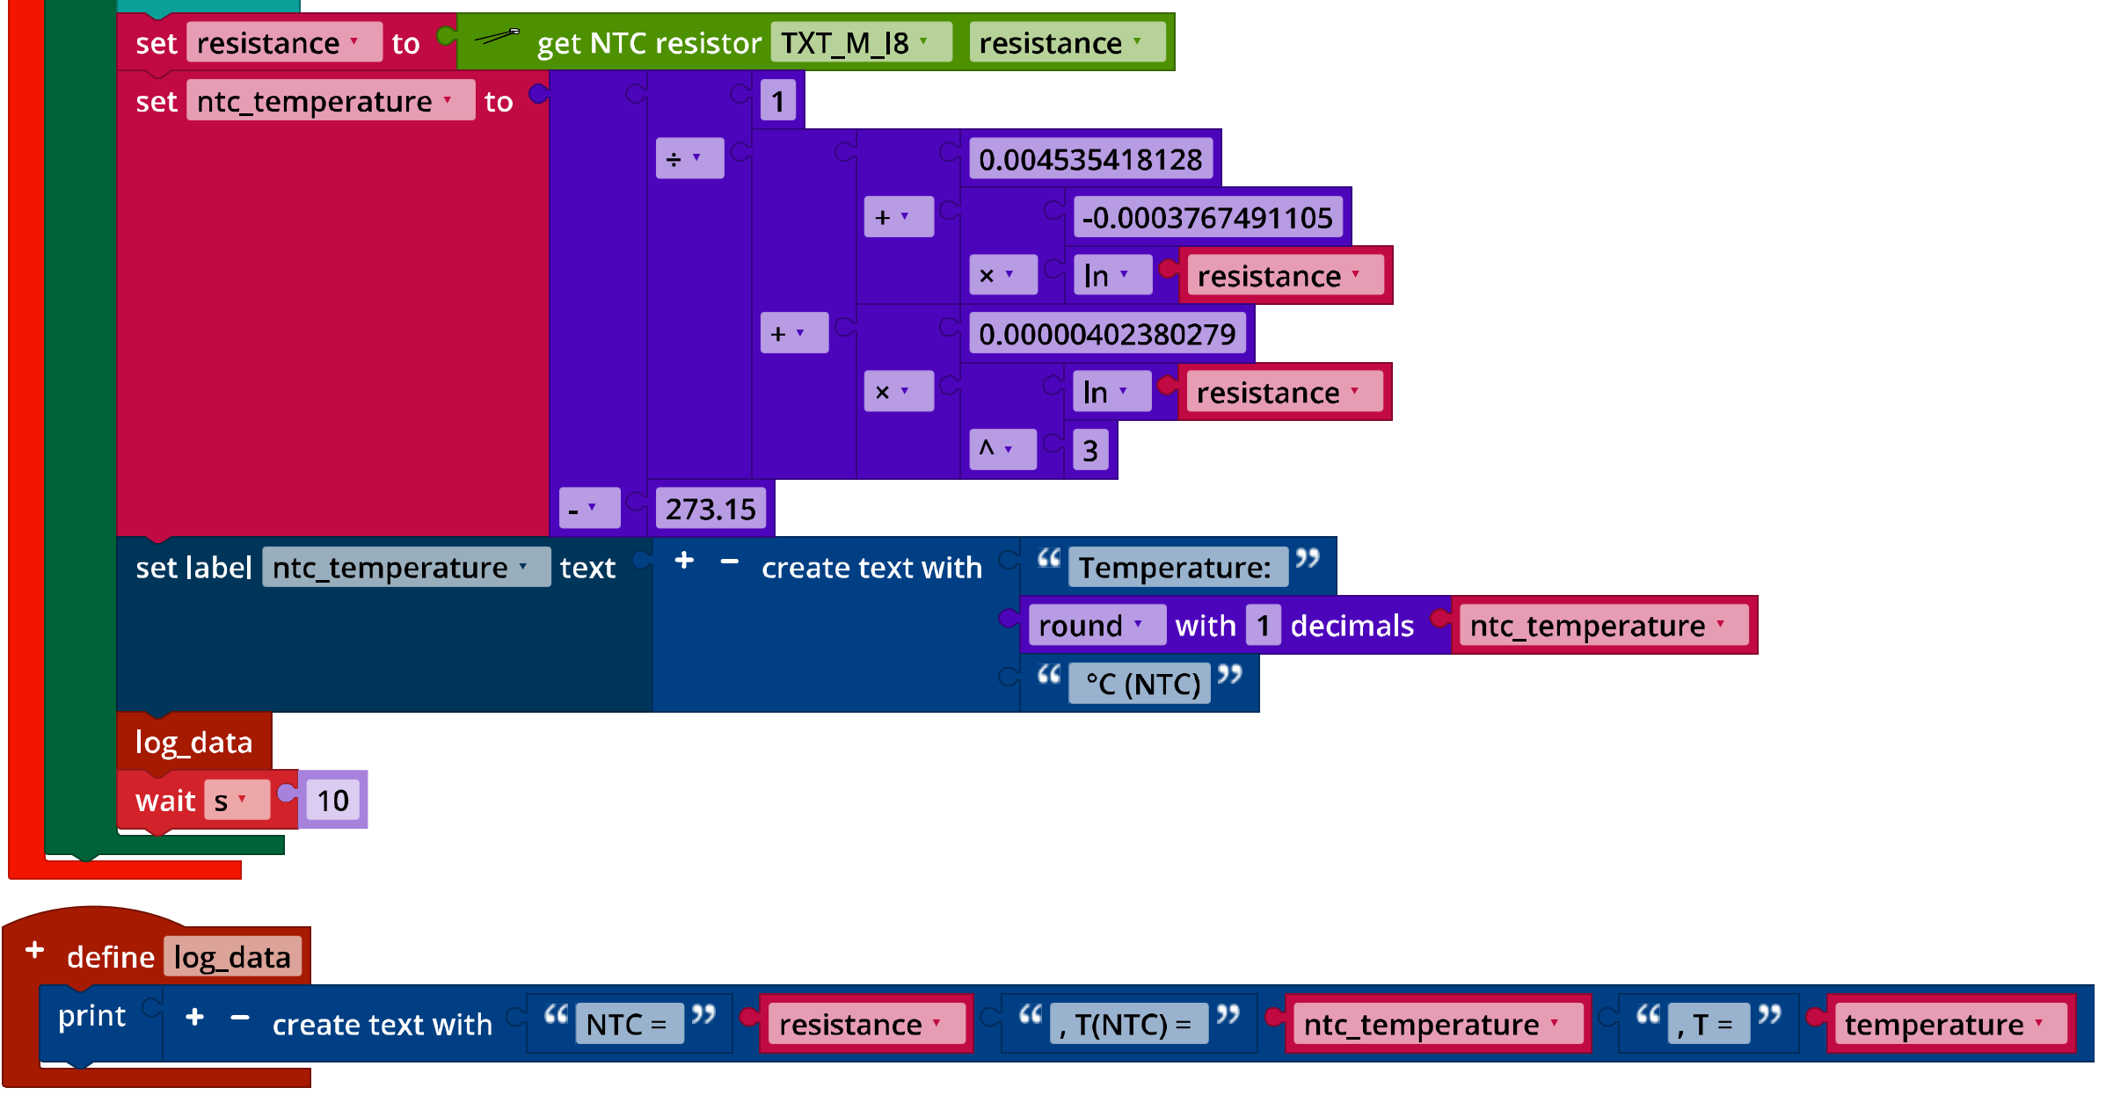
IoT_Barometer_with_NTC_resistor.ft

2. Data visualisation on an IoT server
2a. Configuring the dashboard on the IoT server in the fischertechnik cloud:
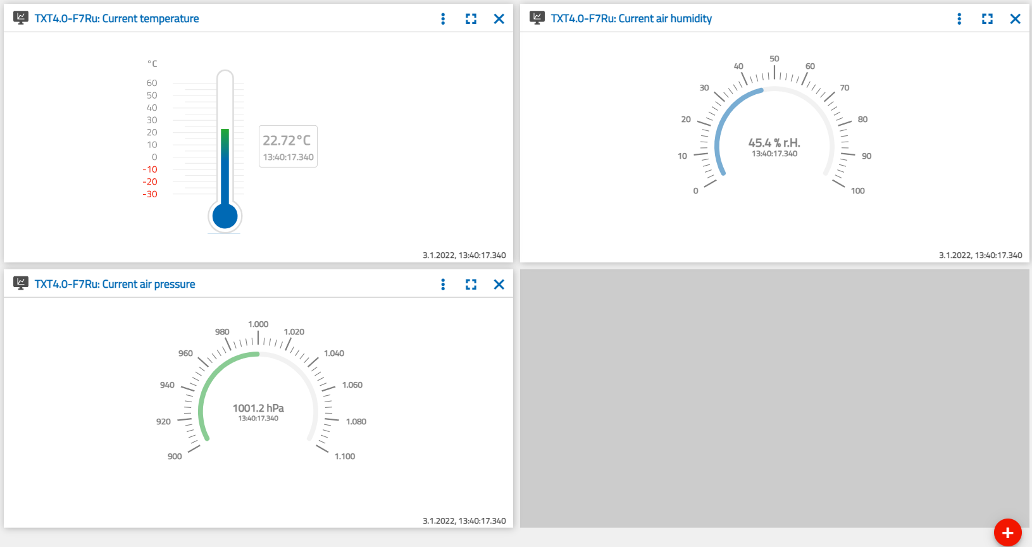
Configuring the display in the dashboard

2b. Expanding the program (example):
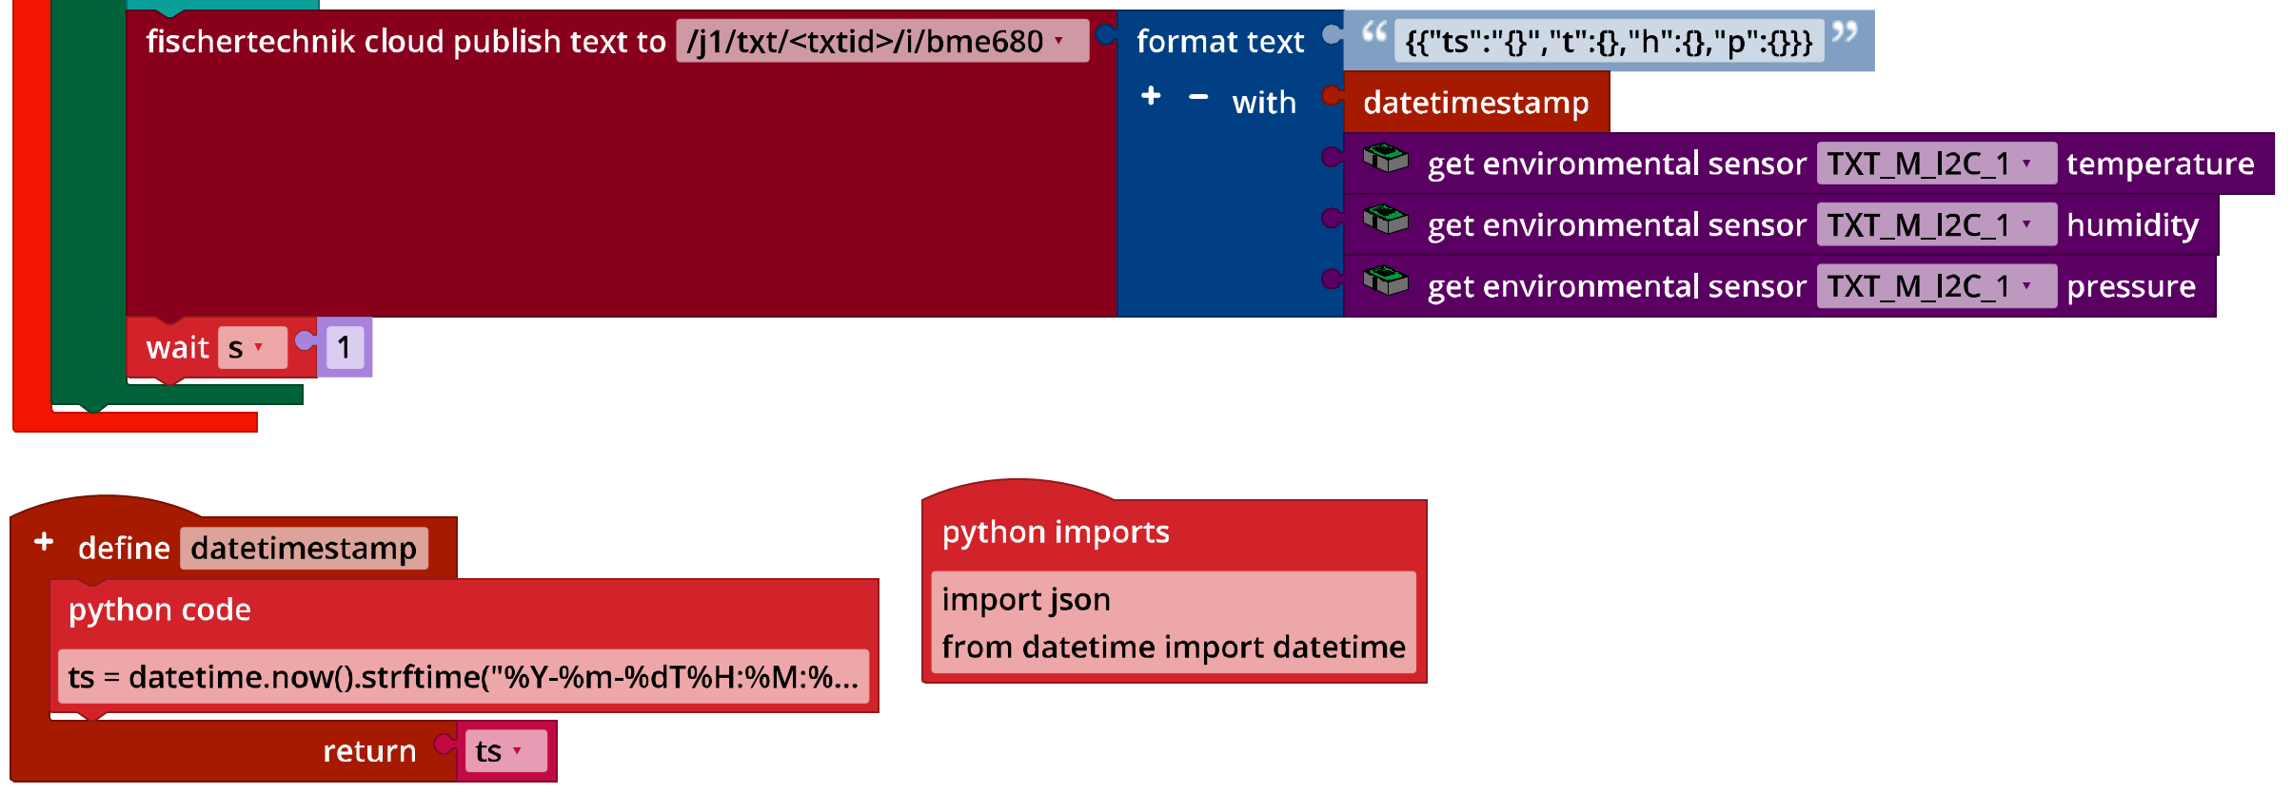
IoT_MQTT_Barometer.ft

3. Webcam
3a. Expanding the dashboard in the fischertechnik cloud:
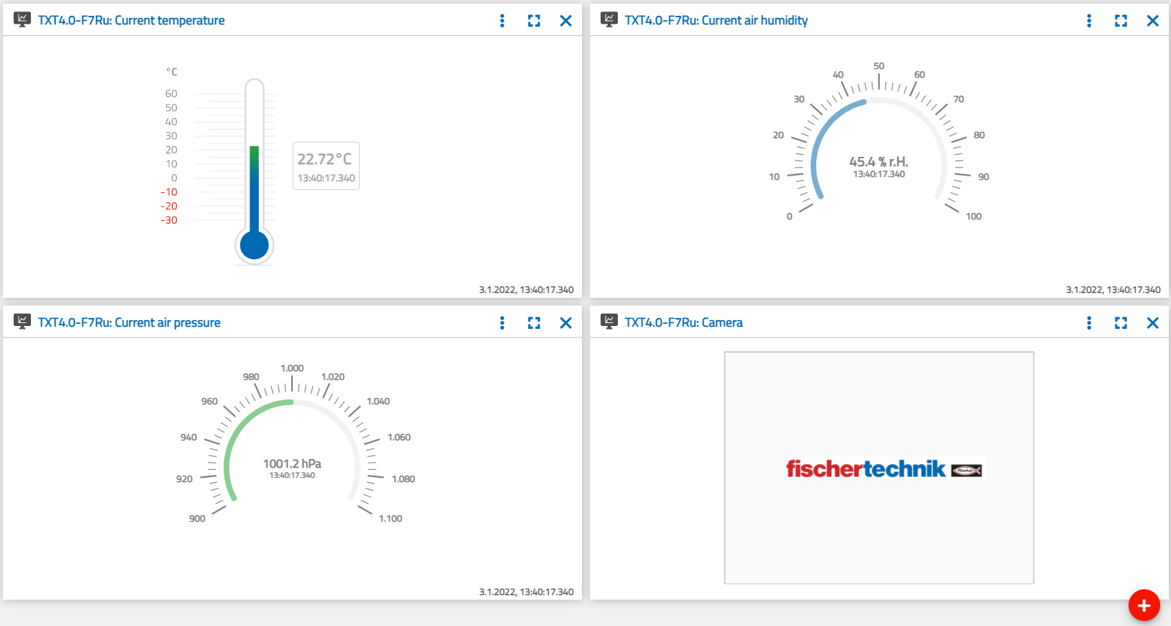
Dashboard with webcam

3b. Expanding the program (example):
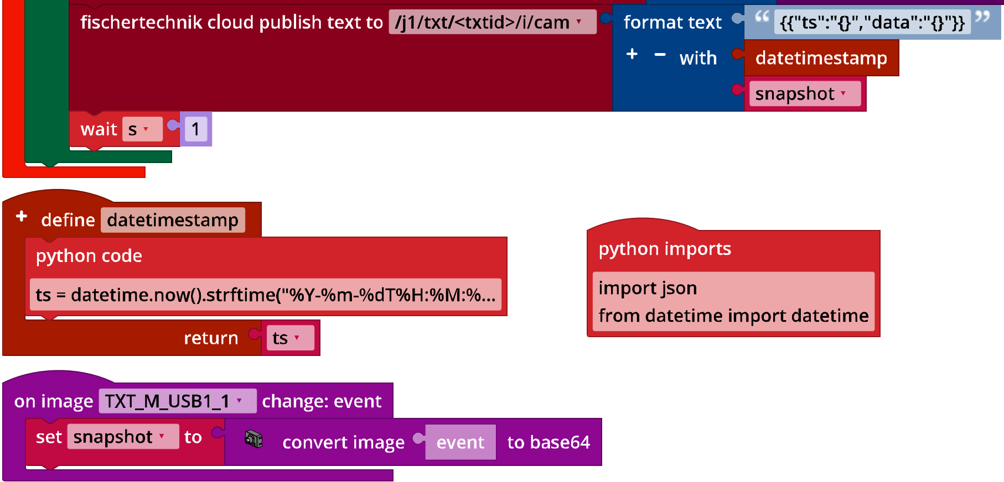
IoT_MQTT_Barometer_with_Webcam.ft

Annex

Task 1: Weather station

Required materials
- PC for program development, local or via web interface.
- USB cable or BLE or WiFi connection for transmitting the program to the TXT4.0.
- Example programs “IoT_MQTT.ft” and “IoT_Webcam.ft”
- Account in the fischertechnik cloud

Further information
[1] Wikipedia: Barometric formula.
[2] Online diagram editor for creating state transition diagrams (drawio format): https://www.diagrammeditor.de/
[3] fischertechnik: NTC resistance. Data sheet, Art. no. 36437.
[4] Stanford Research Systems (SRS): Thermistor Calculator. V1.1
[5] Dirk Fox: “Einmessen” eines digitalen Messgeräts (“Calibrating” a digital measurement device). ft:pedia 1/2013, p. 39-48.

