Name: __________ Class: ___ Date: ________

# Solution sheet task 2:

# Indoor climate

## Construction task

See building instructions.

## Programming tasks

Configuring the sensors and actuators:

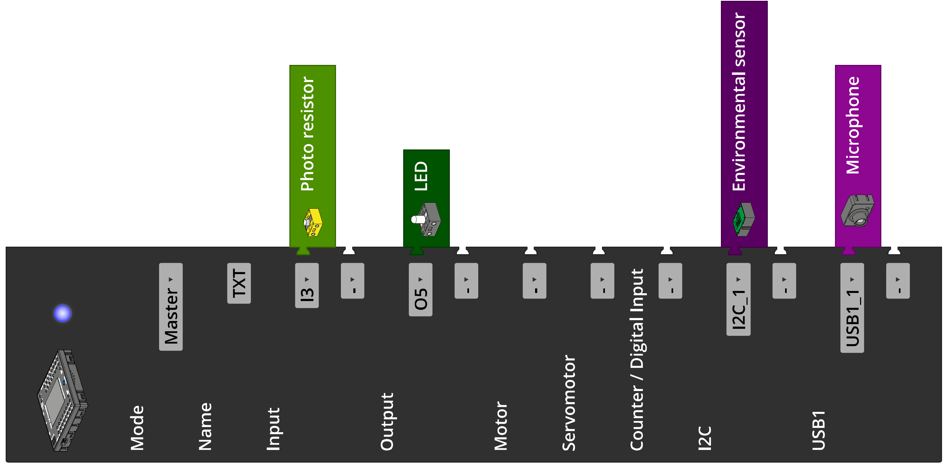

**1. Measuring indoor climate values**

1a. Configuring the TXT display:

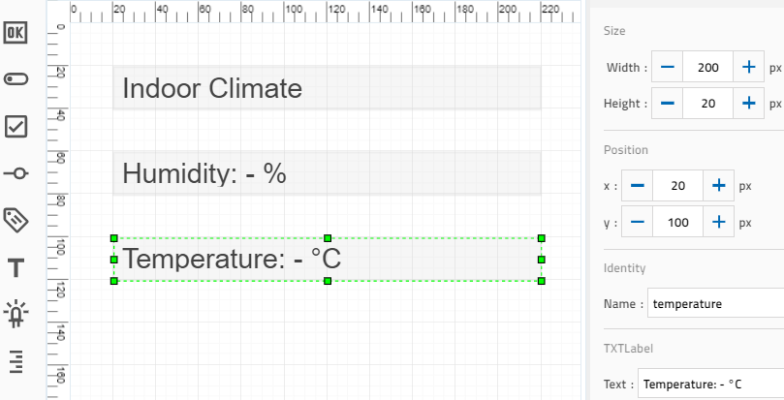

Configuring the display on the TXT

1b. Program (example):

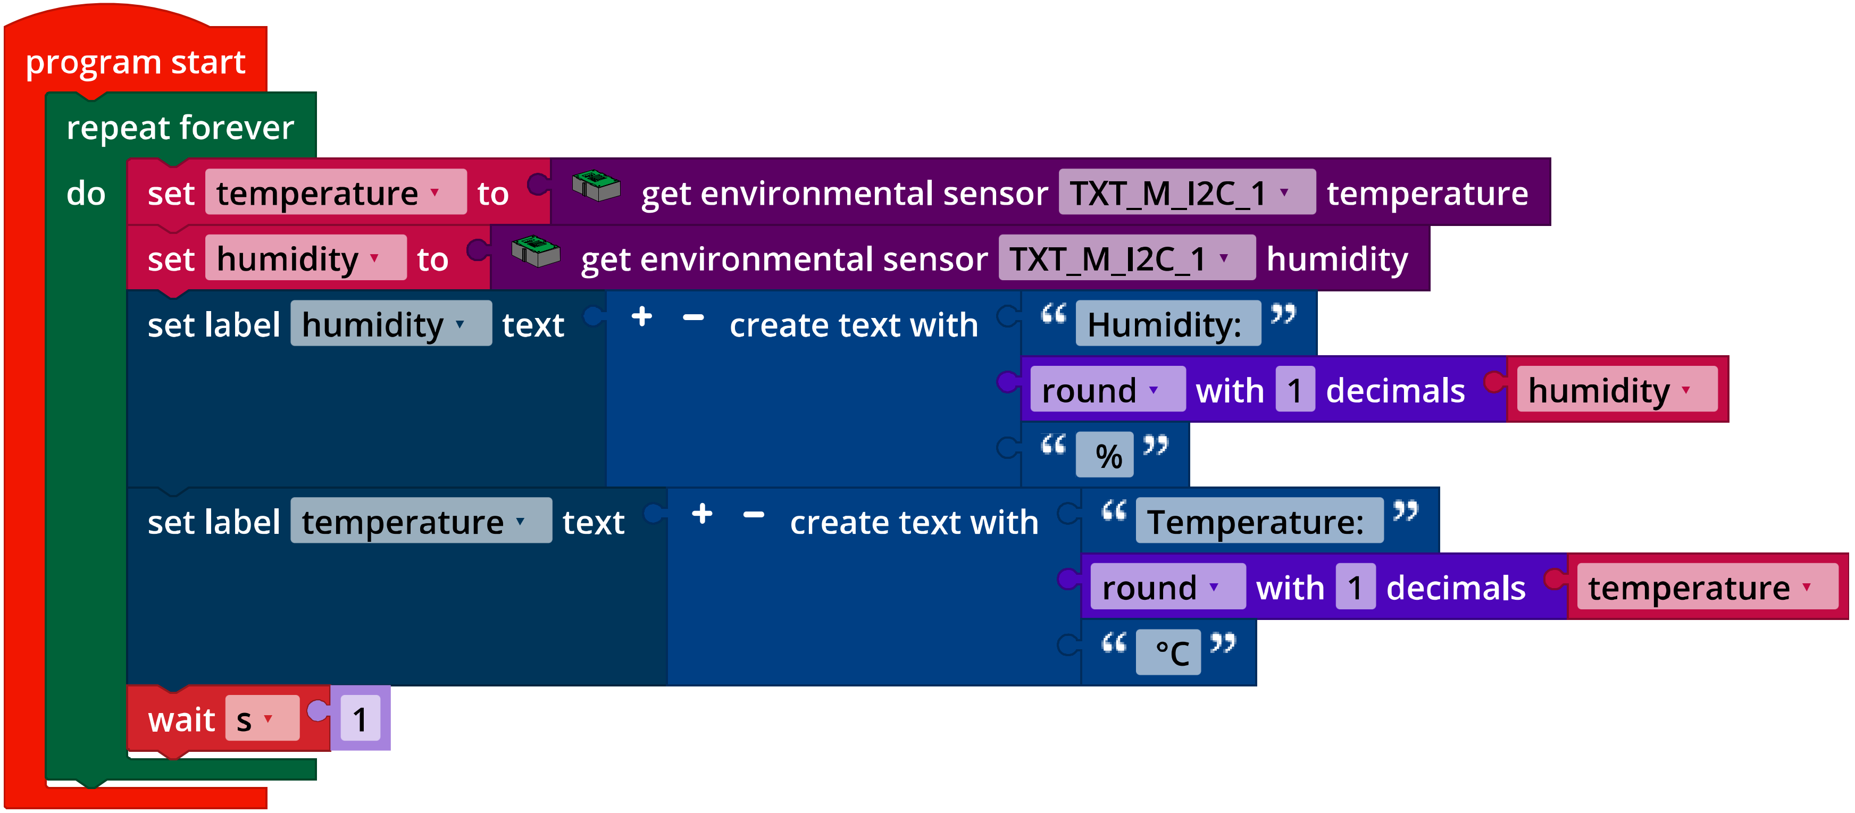

*IoT_Indoor_Climate.ft*

**2. Measuring air quality**

2a. Configuring the TXT display:

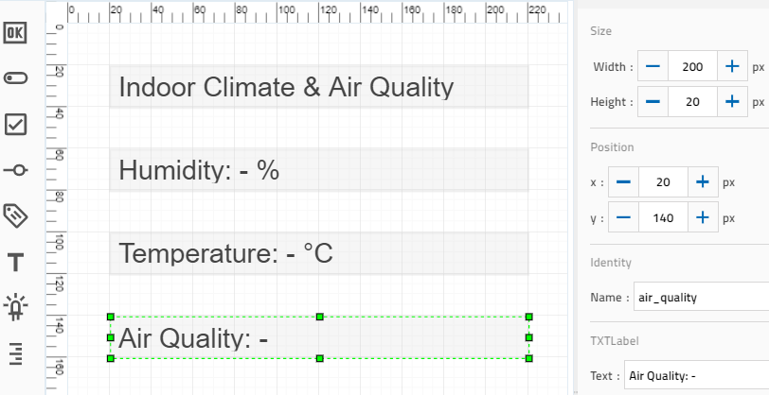

Expanding the display on the TXT

2b. Program (example):

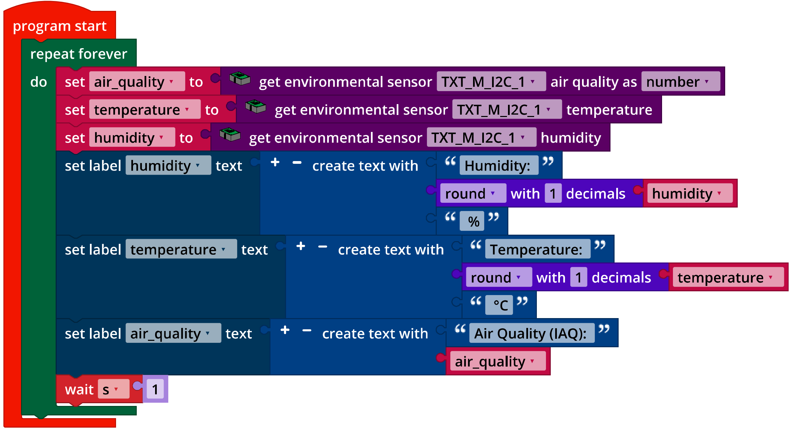

*IoT_Indoor_Air_Quality.ft*

## Experimental tasks

**1. Brightness**

The measured values (resistance/measured illumination level) should be displayed in a graph using a spreadsheet program (x: resistance, y: illumination level).

The resistance value $r$ can be converted approximately into illumination level $i$ using an equation derived from the characteristic curve. The equation displayed, for instance in Excel for an added trend line could be as follows (based on the daylight measurements):

$i={2∙{10}^{8}∙r}^{-1.74}$ lx

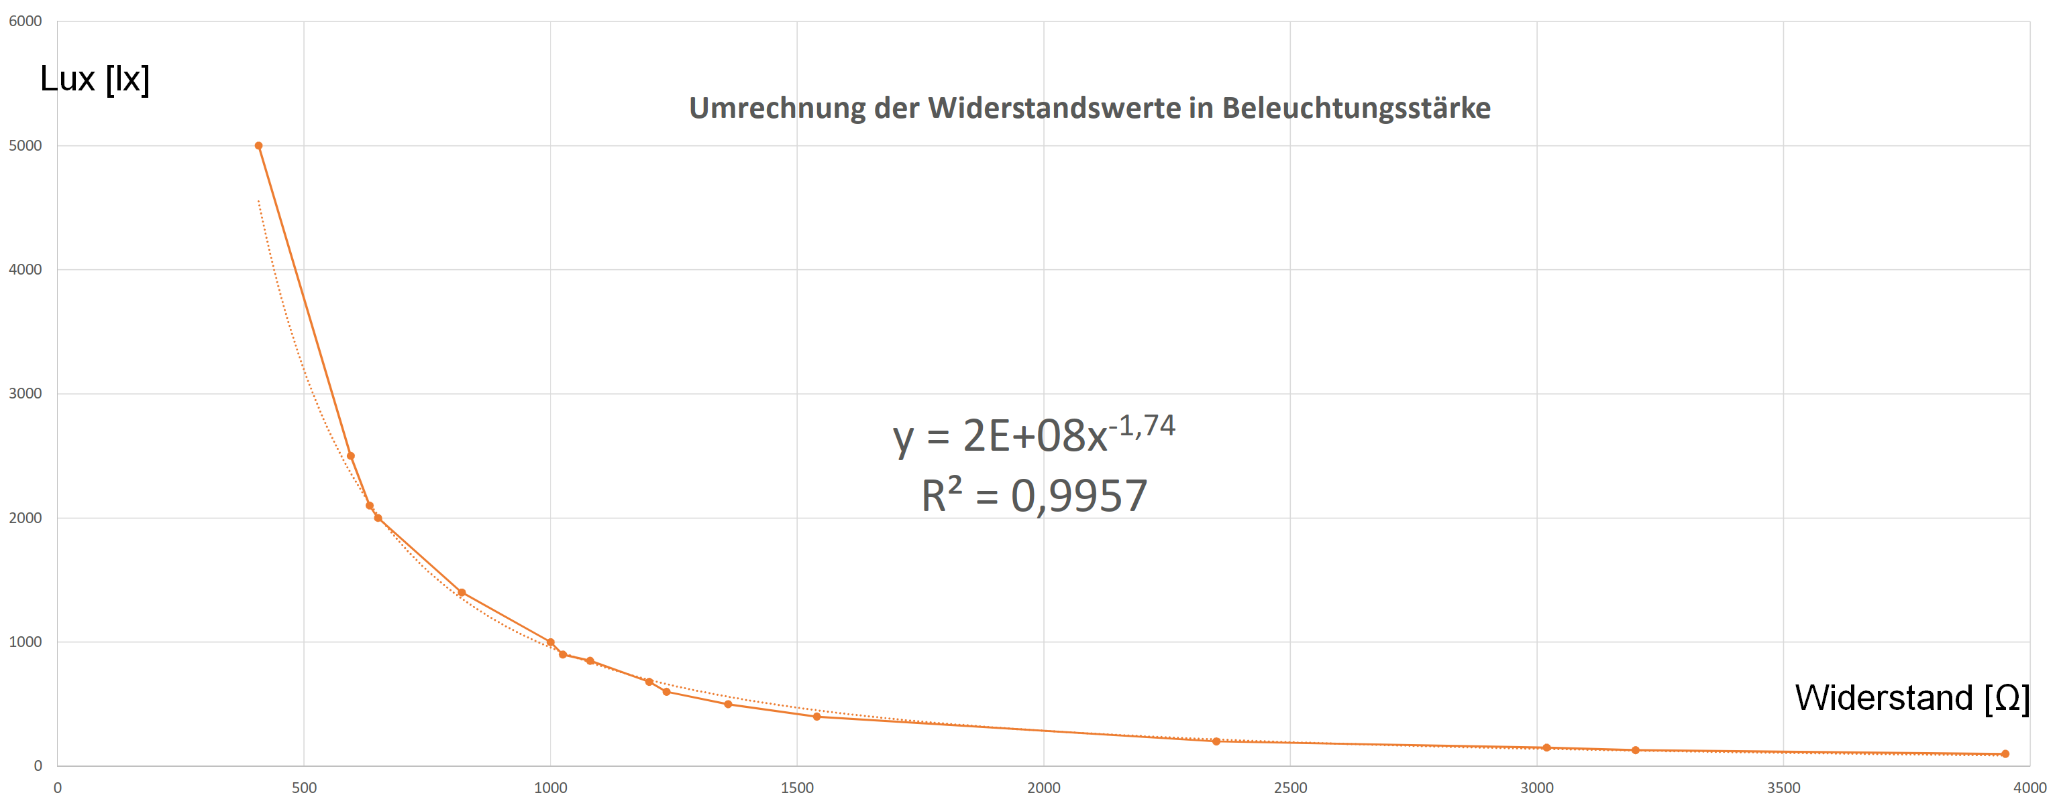

Resistance (Ω)

Conversion of resistance values to illumination level

Lux (lx)

Based on the work station regulations, a work station should have an illumination level of at least 500 lx; this is also a good minimum requirement for a work station in a classroom.

Configuring the TXT display:

Ein Bild, das Tisch enthält.

Expanding the display output on the TXT

Program (example):

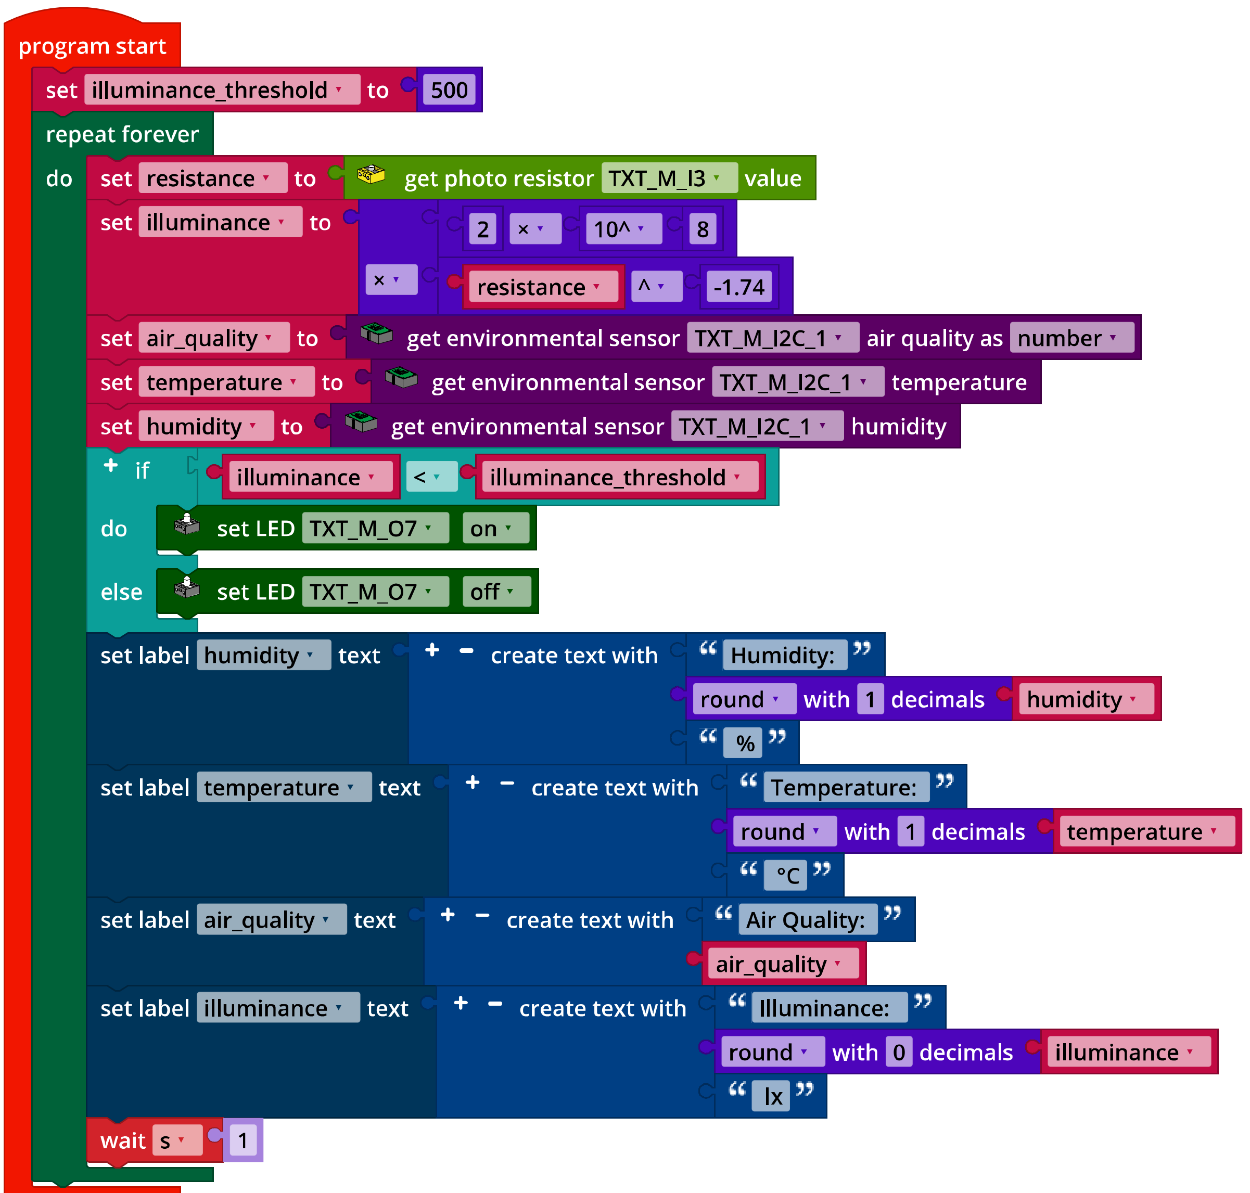

*IoT_Illuminance.ft*

**2. CO2 traffic light**

2a. The “ventilation index” $L$ should have a value up to 100, and should equal zero when the humidity and IAQ each reach the desired target value, and be 100 when the humidity and IAQ reach the “Ventilate now!” level.

If $H_{0}$ is the target value and $H_{1}$ is the threshold value (upper limit) for relative humidity and $H$ is the measured value; and furthermore if Q0 is the target value, Q1 is the threshold value (upper limit) for air quality and Q is the measured IAQ value. Then, we can define the “ventilation index” L as follows:

$$L=\left(\frac{H-H_{0}}{H_{1}-H_{0}}+\frac{Q-Q_{0}}{Q_{1}-Q_{0}}∙3\right)∙25$$

Example calculation: If the relative humidity after ventilation should be 30% and the IAQ should be 30 (target values), and if the threshold values (such as the values after 20 minutes in the classroom without ventilation) are defined at 55% and 100, then:

$$L=\left(\frac{H-30}{25}+\frac{Q-30}{70}∙3\right)∙25$$

Configuration of the IoT dashboard to display the measured values (temperature, relative humidity and air quality):

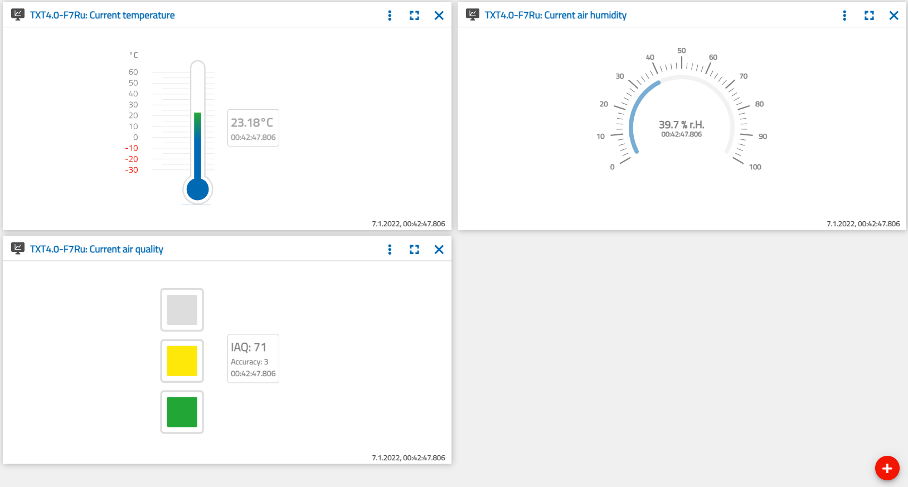

Configuration of the IoT dashboard

2b/c. Program excerpts (example):

Ein Bild, das Tisch enthält.
…  
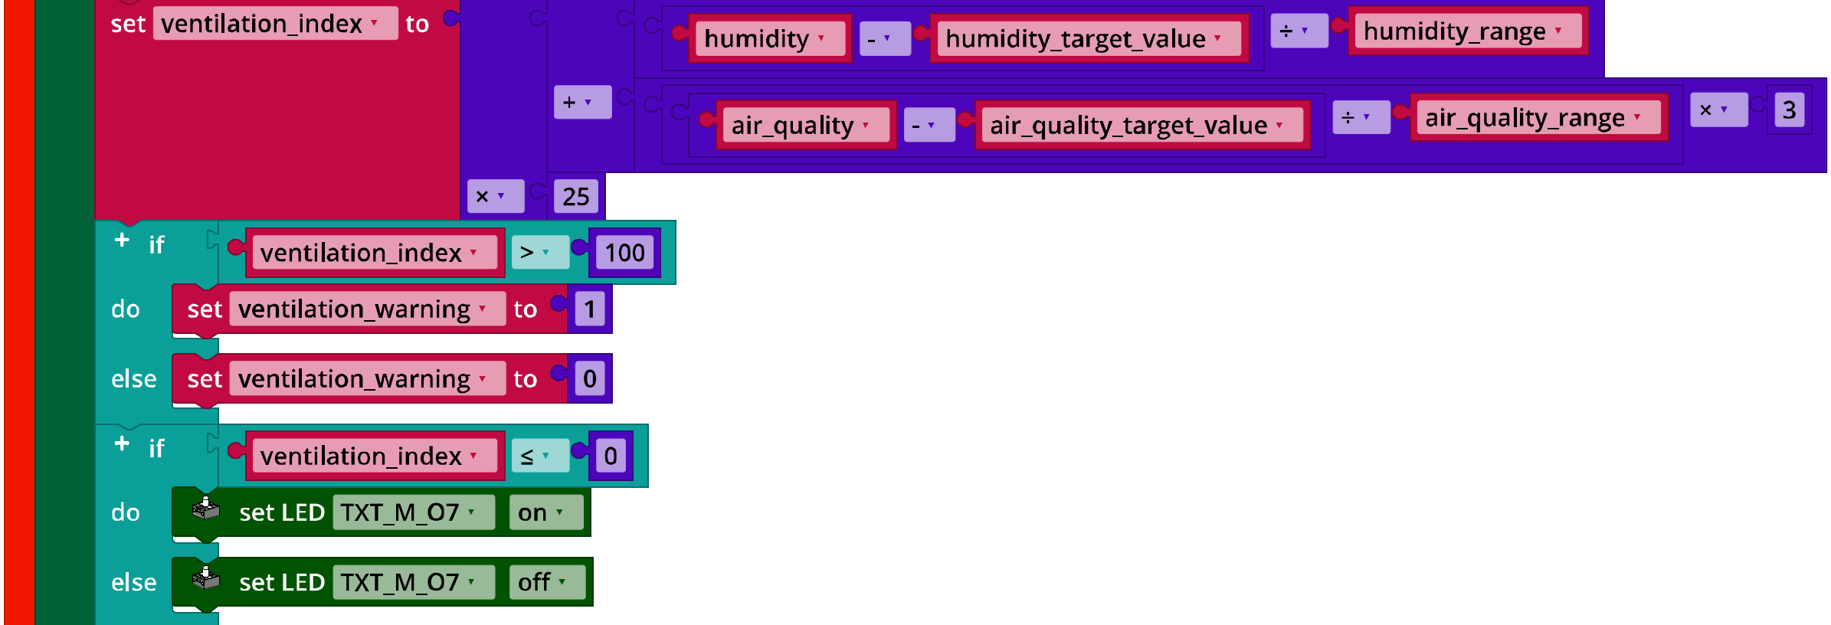  
…  
Ein Bild, das Text, draußen, Schild, Straße enthält.

*IoT_CO2_Signal_Light*

**3. Noise level**

3a. Configuring the TXT display:

Ein Bild, das Tisch enthält.

Expanding the TXT display by adding a volume scale

3c. 70 dB can be selected, for instance, as the limit value for the volume level.

Program (example):

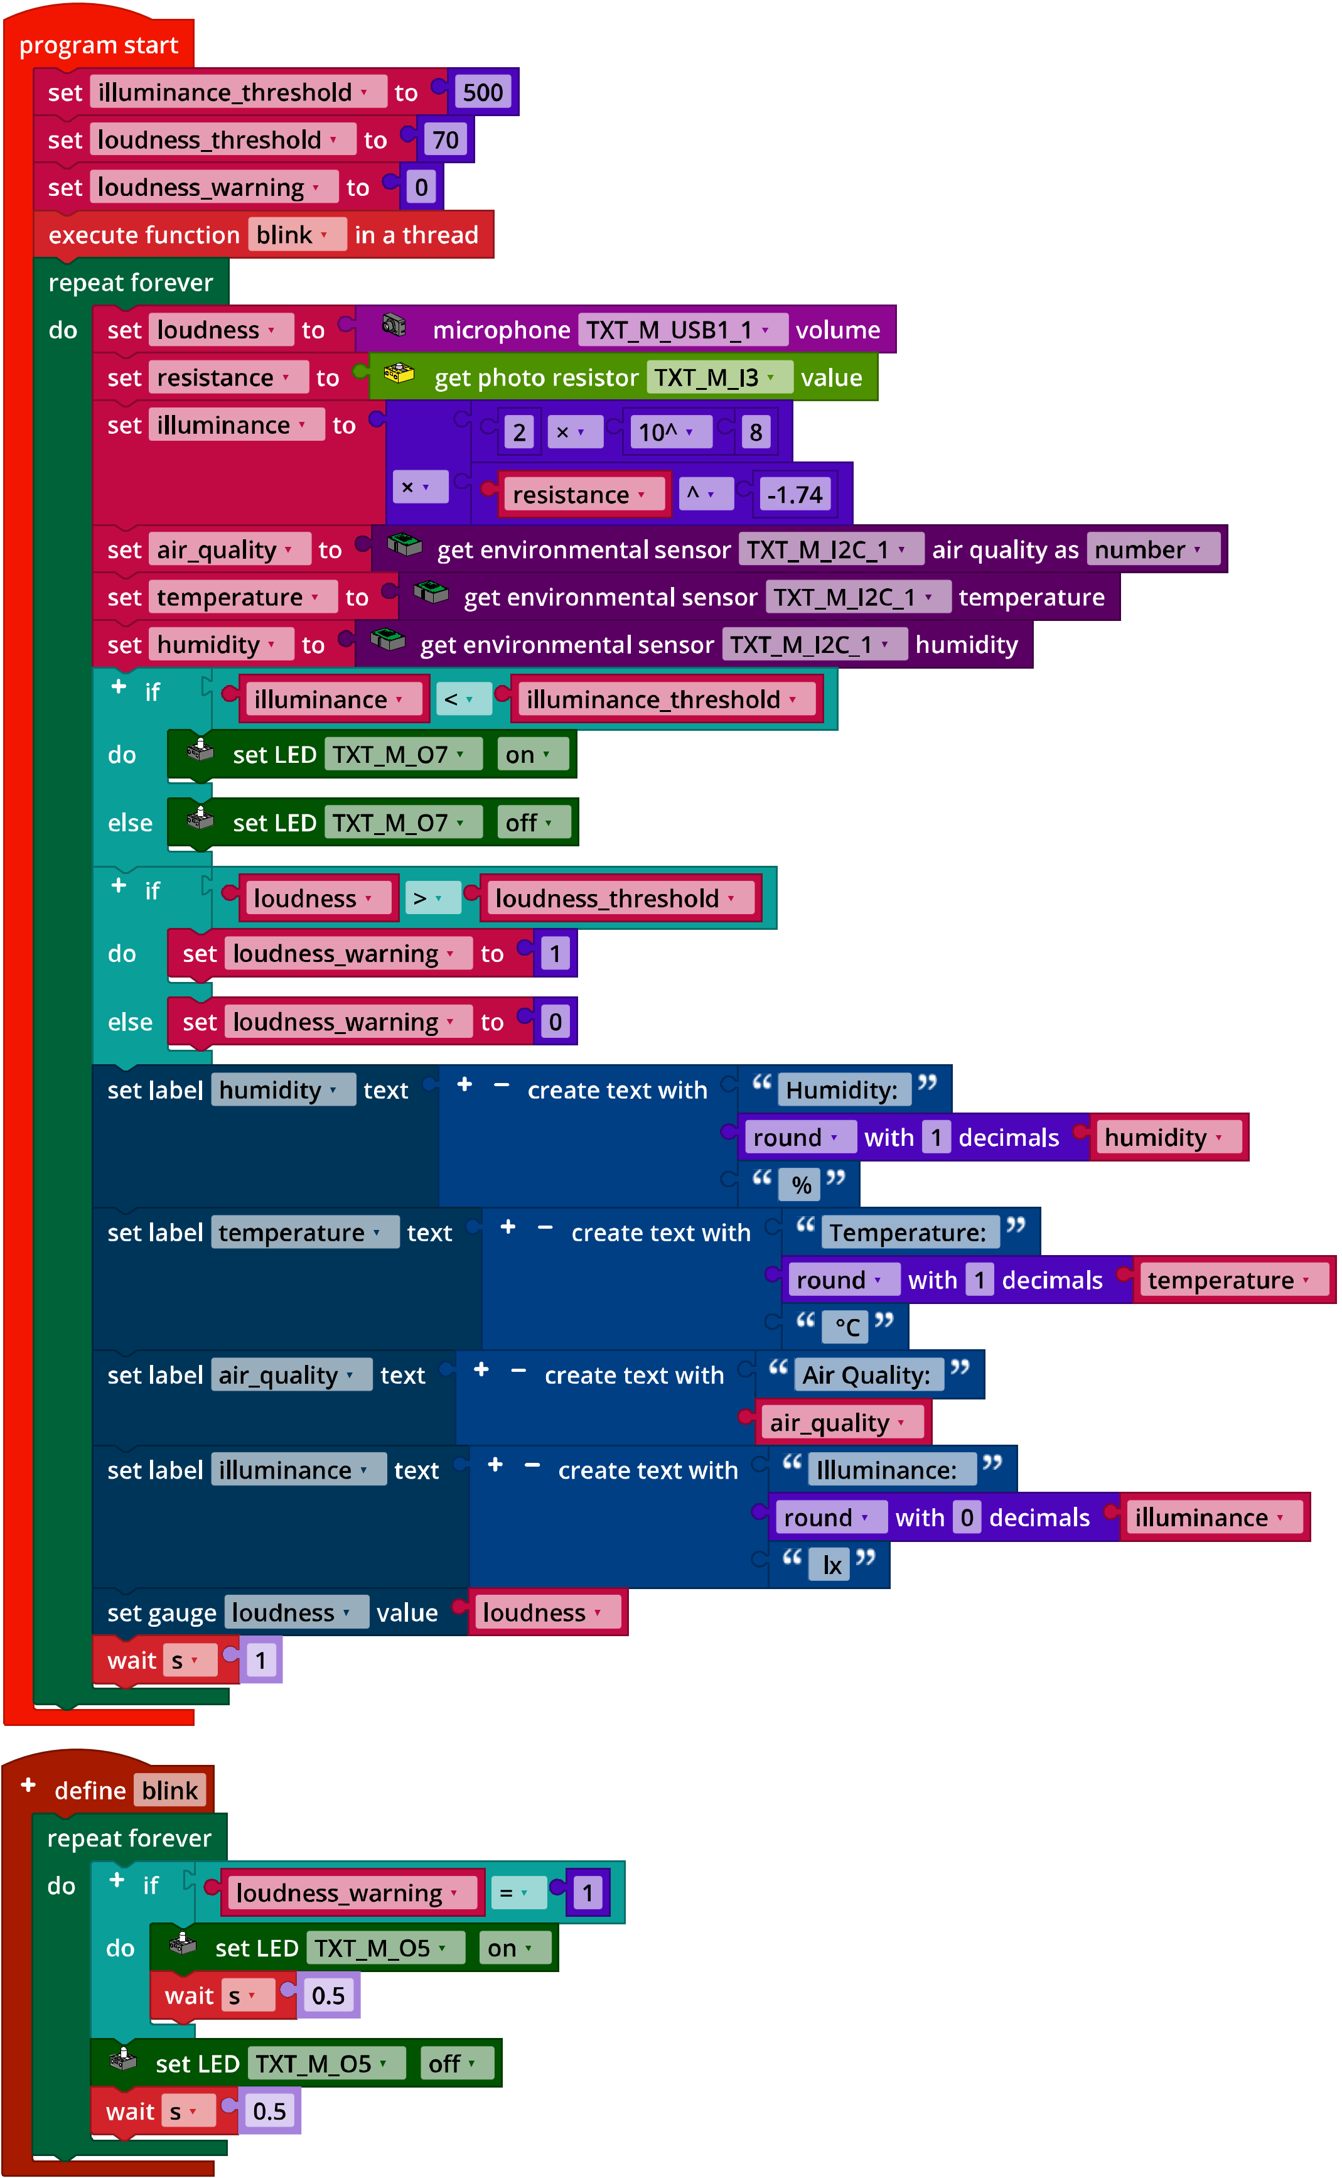

*IoT_Loudness.ft*

Annex

# Task 2: Indoor climate

## Required materials

* PC for program development, local or via web interface.
* USB cable or BLE or WiFi connection for transmitting the program to the TXT4.0.
* Program “IoT_MQTT_Indoor_Air_Quality.ft”

## Further information

[1] Bosch Sensortec: *BME680 – Application Note*. Rev. 1.6, 20.09.2020.

[2] Bosch Sensortec: *BME680 – Data sheet*. Rev. 1.7, 20.12.2021.

[3] fischertechnik: [*Photoresistor LDR03 (32698)*](https://content.ugfischer.com/cbfiles/fischer/Zulassungen/ft/32698-Photoresistor-LDR03.pdf). Data sheet, 17.10.2018.

[4] German Federal Ministry of Labour and Social Affairs: [*Beleuchtung*](https://www.baua.de/DE/Angebote/Rechtstexte-und-Technische-Regeln/Regelwerk/ASR/pdf/ASR-A3-4.pdf?__blob=publicationFile). Technische Regeln für Arbeitsstätten (Lighting: technical work station regulations), ASR A3.4, April 2011.

[5] Federal Environmental Agency: [*Gesundheitliche Bewertung von Kohlendioxid in der Innenraumluft (Health evaluation of carbon dioxide in indoor air)*](https://www.umweltbundesamt.de/sites/default/files/medien/pdfs/kohlendioxid_2008.pdf). Mitteilungen der Ad-hoc-Arbeitsgruppe Innenraumrichtwerte der Innenraumlufthygiene-Kommission des Umweltbundesamtes und der Obersten Landesgesundheitsbehörden, Bundesgesundheitsblatt – Gesundheitsforschung – Gesundheitsschutz (Reports of the ad hoc working group on indoor reference values of the indoor air hygiene commission of the Federal Environmental Agency and Higher State Health Agencies, Federal health gazette - health research - health protection) 2008, 51, p. 1358–1369.

[6] Deutsche Gesetzliche Unfallversicherung (DGUV - German Social Accident Insurance): [*Coronavirus SARS-CoV-2 – Ergänzende Empfehlungen der gesetzlichen Unfallversicherung für die Gefährdungsbeurteilung in Schulen (Supplementary recommendations of the social accident insurance for risk assessment in schools)*](https://publikationen.dguv.de/widgets/pdf/download/article/3873). 03/12/2021