Name: __________ Class: ___ Date: ________

Task 2

Indoor climate
In this task, our sensor station will monitor the indoor climate and warn us if it is too hot, too moist, too dark, or too loud – or if the air quality drops (for instance due to excessive CO₂).

Construction task
You can use the sensor station you built in task 1 without modification.

Programming tasks

1. Measuring indoor climate values
You can use the measured values for “humidity” and “temperature” collected in task 1 to determine not only the weather, but also the indoor climate.
Humidity and temperature are important factors for a good indoor climate. The (absolute) humidity indicates the quantity of water (in g) which is present in a cubic meter (m³) of air as water vapour.
The sensor measures the relative humidity, or the quotients of (absolute) humidity and the maximum possible humidity in %. The maximum humidity changes with the temperature: At 0°C, air can absorb a maximum of 5g of water vapour, at 30°C, however, it can absorb 30g – therefore, cold air is “dryer” than warm air.
A relative humidity of 45-55% at a temperature of 20°C is considered the optimal indoor climate for living and working areas.

1a. Adjust the display configuration for the weather station from task 1 so that it displays relative humidity and temperature.

1b. Modify the Blockly program for the weather station to make it into an indoor climate station.

Note: The sensor will need around 10 seconds after the program is started for the measured values to stabilise [1].
2. Measuring air quality
The environmental sensor can detect a variety of gases in the ambient air, such as formaldehyde, alcohol, solvents, and evaporating varnishes, stains, cleaning agents, or adhesives. It can use these to determine an Index for Air Quality, IAQ in a range of 0-500.
An IAQ value below 50 indicates good air quality, while a value over 200 indicates significant contamination in the air (see table).

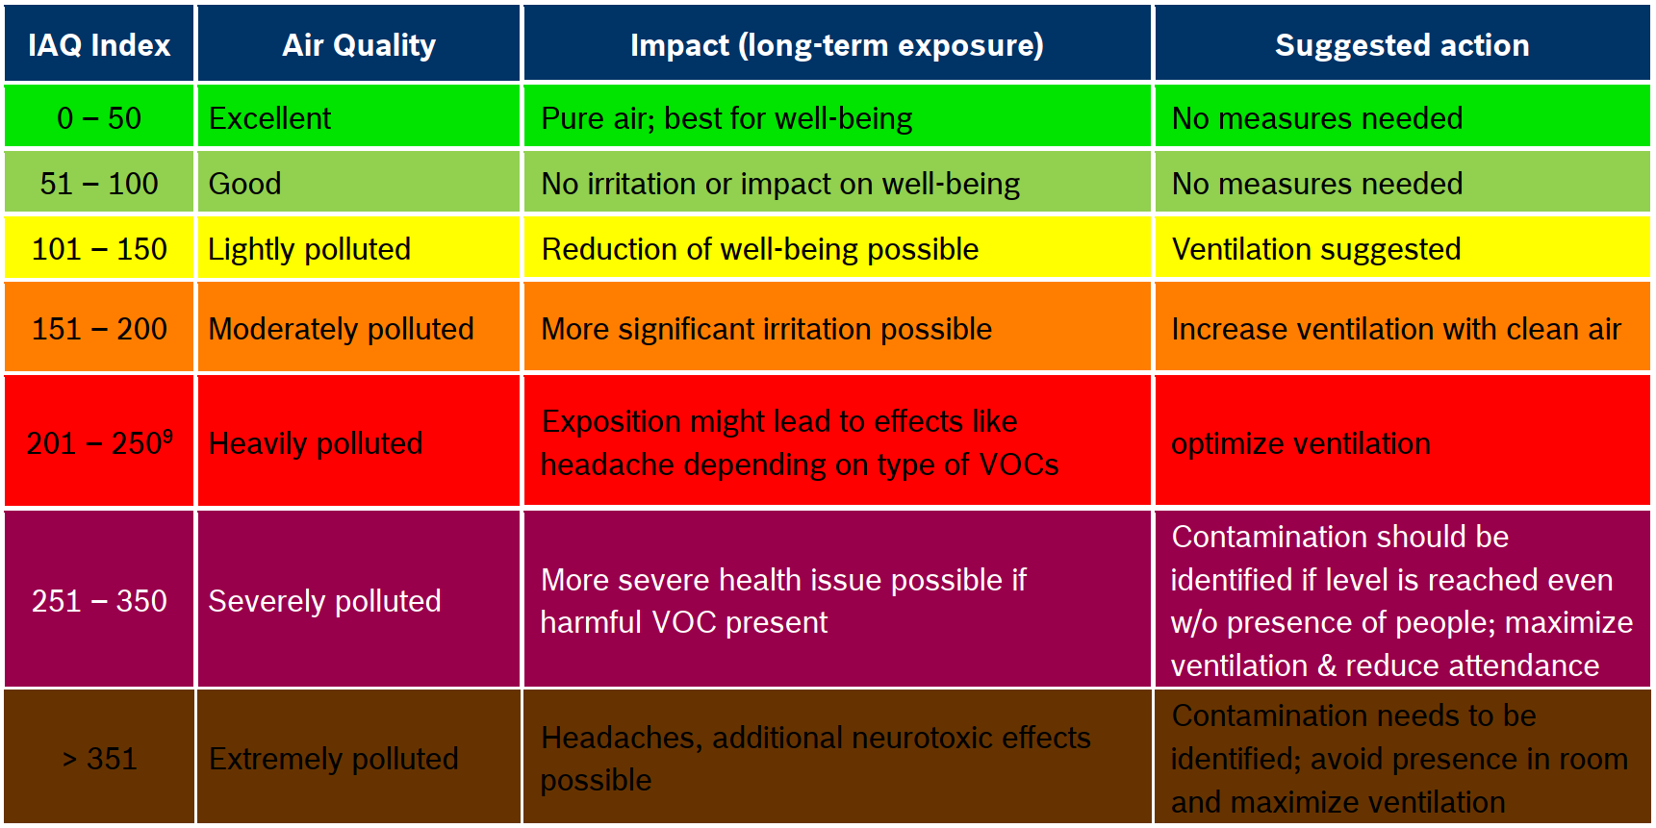
Index of Air Quality [2]

2a. Adjust the display configuration of the indoor climate station so that it outputs the air quality.

2b. Expand the Blockly program for the indoor climate station accordingly.

Note: When the program is started, the air quality sensor is calibrated automatically. The calibration process will take five minutes, and the progress is displayed on the console. During this time, -1 will be indicated as the IAQ value.

Experimental tasks

1. Brightness
In contrast to the phototransistor, which was used in task 2 of the Robotics Base Set as a sensor in a light barrier, a photoresistor (LDR – Light Dependent Resistor) is not a digital sensor, but rather an analogue one. We can use it to determine the ambient brightness.
Lux (1x) is the unit for illumination level – the luminous flux (measured in lumens) that strikes a certain surface. The following formula applies: 1 Lux = 1 Lumen/m². A lux corresponds to around the illumination level that can be measured at one meter's distance from a candle flame.
For comparison: On a cloudless summer day, the illumination level under direct sunlight can reach 100,000 lux, but on a cloudy winter day it will be only around 2,000 lux.
The fischertechnik photoresistor delivers resistance values up to more than 60 kOhm; the brighter it is, the lower the resistance. A resistance value of 1 kOhm corresponds to around 1000 lux, the so-called “resistance under illumination”). The characteristic curve for resistance indicates the relationship between resistance value and illumination level. It is logarithmic (note the scales):

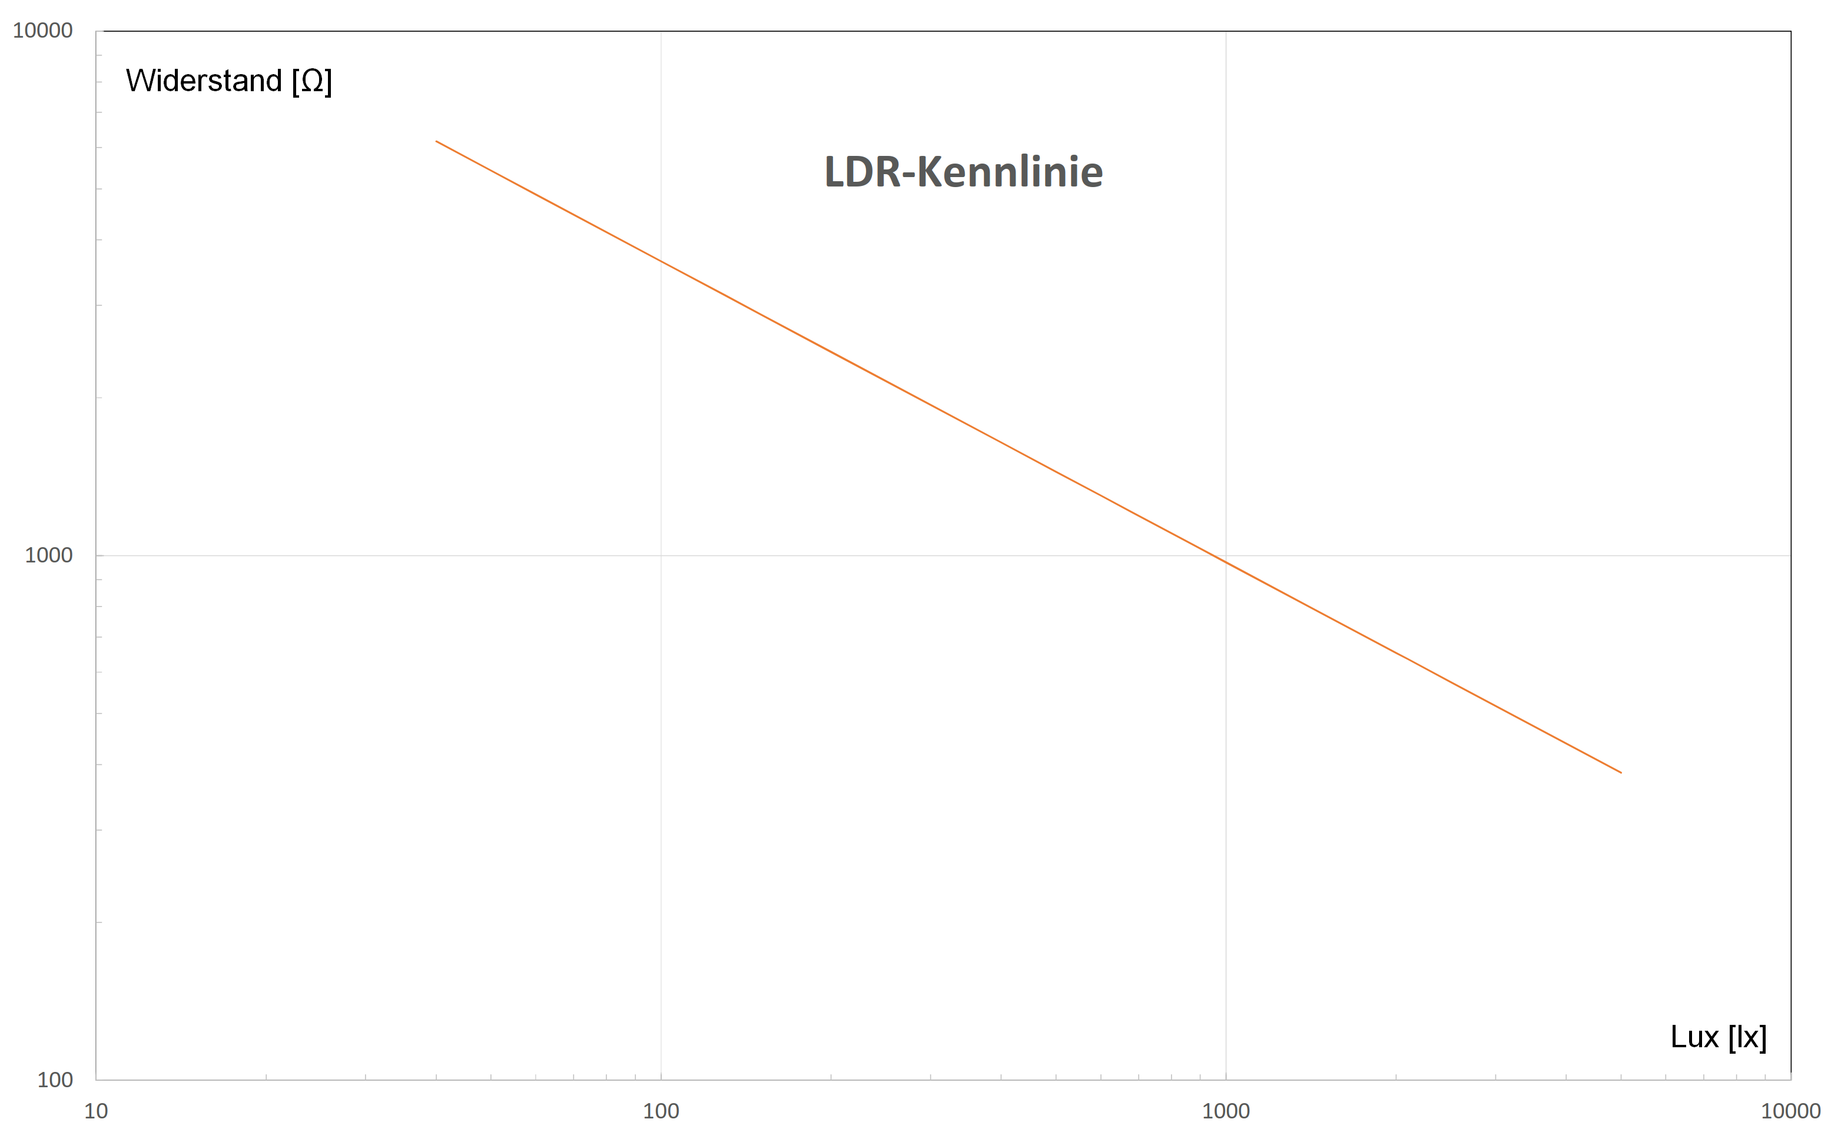
LDR characteristic curve
Lux (lx)
Resistance (Ω)
1a. Now, use a light meter (an app, for example) to complete multiple measurements, and enter the resistance value and measured lux value in a table. You can use a spreadsheet program to obtain a simple formula for your measured values in the form of y = a·x^{b}, which you can use to calculate the approximate illumination level in lux based on the resistance value.

1b. Add a display of illumination level in lux to the Blockly program from programming task 2.

1c. Define a suitable threshold value for the minimum illumination level in the classroom. What do the workplace regulations require, for instance [4]? Connect the second LED to O7 and O8 (ensure correct polarity). It should be switched on by your Blockly program if it gets too dark in the room.

2. CO₂ traffic light
The environmental sensor cannot determine the level of CO₂ in the air directly, but it can detect the air breathed out by people using the other gases contained in it. Therefore, the air quality measured by the sensor is directly connected to the CO₂ content in the air as a result of breathing out.
The CO₂ content in the air is around 400 ppm (parts per million). Since people emit around 40,000 ppm (= 4%) CO₂ in the air they breathe out (8-10 litres per minute), the percentage of CO₂ in the air increases continuously in an enclosed room where multiple people are present. If it reaches 1,200 ppm, 2% of the air in the room would have already been breathed out once – therefore, every 50th breath would consist of air that had been breathed out. A CO₂ level of 1,000-2,000 ppm, therefore, is considered concerning by the Federal Environmental Agency; in schoolrooms in particular, an average of 1,000 ppm should not be exceeded [5].
Small droplets (aerosols) are also contained in the air we breathe out; these may contain viruses that can stay in the air for a long time (dropping at a speed of 10 cm/h at a virus infectious activity half-life period of 2.7 hours). Therefore, increasing humidity in the air is a risk indicator that viruses may be spreading in the room.
Briefly ventilating the area to allow air to pass through can quickly and effectively reduce the CO₂ level and humidity. Ventilating every 20 minutes is recommended in classrooms to protect against infection [6].

2a. First, determine threshold values for humidity and air quality that should be used for ventilating the classroom. To do so, you can determine the measured values in the classroom after 20 minutes, for example. Target values are the humidity and air quality levels you can achieve through ventilating.
You can display the curve for measured values, relative humidity, and air quality using the following auxiliary program in the dashboard of the IoT server:
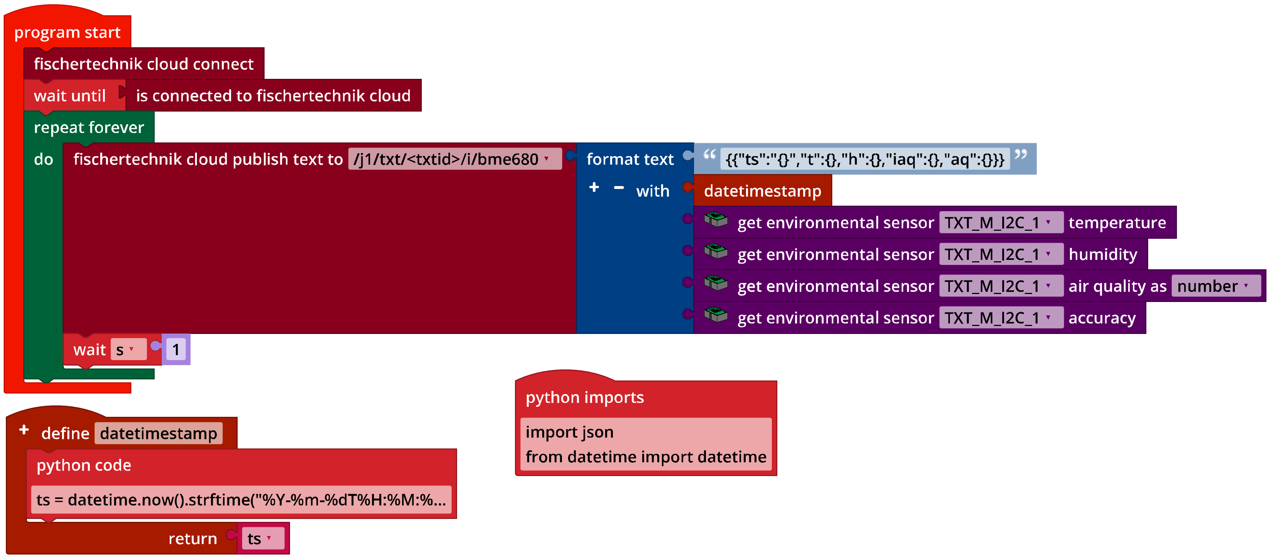
IoT_MQTT_Indoor_Air_Quality.ft
Use the threshold values to derive a “ventilation index” (0-100 with: 0 = ideal state after ventilation, 100 = ventilation urgently required), including the relative humidity and air quality in the calculation with a weighting of 1:3.

2b. Program a sub-program that causes the red LED to flash every 0.5 seconds. The red flashing light should be activated at a ventilation index of 100.

2c. Connect the second LED (with the green cap) to O7 and O8 (note the polarity) and activate it when your ventilation index reaches “0”. Compare the ventilation duration when only one window, two windows, ... all windows and door(s) are opened.

3. Noise level
The noise level in our environment can also influence our well-being. Volume is measured as the sound pressure level, and is stated using the unit decibels (dB). 0 dB corresponds to the human auditory threshold (pressure fluctuations around 20 micropascal); 120 dB is usually the pain threshold for human listeners.
The (perceived) volume increases logarithmically with the decibel level: It is roughly doubled every time the sound pressure level increases by 10 dB. The sound pressure level, in turn, depends on the distance from the source of the noise: Tripling the distance will cut the volume in half (reduction in sound pressure level by 10 dB).
Comparisons can help us get a feeling for the volumes of certain decibel levels: A ticking alarm clock (1 m distance) is around 30 dB, a normal discussion is around 60 dB, a bus driving by is around 80 dB, a pneumatic drill is 100 dB, and a jet aircraft is 120 dB.
High volume levels can have significant negative impacts:
- People can have trouble concentrating at just 40 dB
- Volumes above 60 dB can cause heating damage following long-term exposure
- The risk of cardiovascular illness increases at continuous levels over 65+ dB
- Over 120 dB, hearing damage may occur after just a short time

3a. Add a scale to display volume (in dB) to the display of your program from programming task 2 (or experimental task 1).

3b. The microphone in the camera will indicate the volume received in dB. Add the volume measurement and display to your Blockly program.

3c. Define a threshold value above which the red LED should flash. Expand your program accordingly.

Annex

Task 2: Indoor climate

Required materials
- PC for program development, local or via web interface.
- USB cable or BLE or WiFi connection for transmitting the program to the TXT4.0.
- Program “IoT_MQTT_Indoor_Air_Quality.ft”

Further information
[1] Bosch Sensortec: BME680 – Application Note. Rev. 1.6, 20.09.2020.
[2] Bosch Sensortec: BME680 – Data sheet. Rev. 1.7, 20.12.2021.
[3] fischertechnik: Photoresistor LDR03 (32698). Data sheet, 17.10.2018.
[4] German Federal Ministry of Labour and Social Affairs: Beleuchtung. Technische Regeln für Arbeitsstätten (Lighting: technical work station regulations), ASR A3.4, April 2011.
[5] Federal Environmental Agency: Gesundheitliche Bewertung von Kohlendioxid in der Innenraumluft (Health evaluation of carbon dioxide in indoor air). Mitteilungen der Ad-hoc-Arbeitsgruppe Innenraumrichtwerte der Innenraumlufthygiene-Kommission des Umweltbundesamtes und der Obersten Landesgesundheitsbehörden, Bundesgesundheitsblatt – Gesundheitsforschung – Gesundheitsschutz (Reports of the ad hoc working group on indoor reference values of the indoor air hygiene commission of the Federal Environmental Agency and Higher State Health Agencies, Federal health gazette - health research - health protection) 2008, 51, p. 1358–1369.
[6] Deutsche Gesetzliche Unfallversicherung (DGUV - German Social Accident Insurance): Coronavirus SARS-CoV-2 – Ergänzende Empfehlungen der gesetzlichen Unfallversicherung für die Gefährdungsbeurteilung in Schulen (Supplementary recommendations of the social accident insurance for risk assessment in schools). 03/12/2021

