Name: __________ Class: ___ Date: ________

Task 3

Alarm system
Now, you will turn your sensor station into an alarm and surveillance station: It should react to noises and movements, and allow you to monitor the room using the IoT dashboard.

Construction task
You can use the sensor station you built in task 1 without modification.
Before testing the program, you should check to ensure the wiring provides enough play to turn the camera to the left and right at a wide angle.

Programming tasks

1. Home position
The camera in your alarm system must first be moved to home position. To do so, you must first turn the camera horizontally and vertically – based on the respective drive motor – anti-clockwise until the associated stop position sensors are activated, so that you know the exact position of the camera. From there, you can turn it to the desired home position.
1a. By how many pulses of the encoder motor must the camera be turned upward vertically from the end position to align it horizontally to the front? Determine the value first using the gear ratio.
Then, check the result experimentally using an appropriate Blockly program that first turns the camera to the end position, and then aligns it horizontally.
Note: As a reminder: The encoder motor outputs 63.9 pulses per axis rotation.

1b. By how many pulses of the encoder motor must the camera be turned clockwise horizontally from the end position to align it “straight ahead”? Determine the value first using the gear ratio. Then, check the result experimentally using an appropriate Blockly program that first turns the camera to the end position, and then aligns it to the front.
Note: The slewing ring has 58 teeth.

1c. Combine both programs into a function that aligns the camera in both dimensions. How can you conduct the two motions in parallel?

2. Camera surveillance
In task 1, you programmed the weather station so that it sent an image from the webcam to the dashboard every second. You can now monitor the room with the camera in the same way.
Expand your program from programming task 1 by adding image transmission to the dashboard. Determine the maximum number of images you can transmit each second that will be displayed on the dashboard.

3. Noise activation
Security personnel can become fatigued if they have to continuously watch screens where nothing is happening. Therefore, image transmission should begin only when the microphone registers an unusual noise.

3a. First, test the “normal” noise level in the room using a simple Blockly program. Display the values on the TXT. Then, set a suitable threshold value above which image transmission should begin.
Note: The Blockly command for the microphone will indicate the measured volume to you in decibels (dB).

3b. Write a Blockly program that begins transmitting the camera image each second once the threshold value you have defined for noise level has been exceeded. If things stay quiet for more than one minute, image transmission should stop.

4. Motion detection
You can also set the camera surveillance so that it is activated by a motion in the room. Configure the camera motion detection for this purpose.

4a. Expand your Blockly program from programming task 3 so that image transmission is also activated when a motion is detected.
4b. The red LED should also flash while the camera is activated.

Experimental tasks

1. Voice control
The camera should now be controlled using voice commands, so that it can monitor a larger portion of the room. To do so, download the “Voice Control” app from the Apple app store (for iOS) or the Google Play store (for Android), and connect it to the TXT 4.0.
- Connection via WiFi: The TXT 4.0 Controller and device (smartphone or tablet) must be connected to the same WiFi router. The router must also permit communication between the devices. The IP address of the TXT 4.0 with which the app must be connected can then be queried via the touchscreen menu under “Info” / “WiFi”.
- Connection via WiFi AP: Instead of “WiFi”, the “Access Point” option can be activated on the TXT 4.0 under “Settings” / “Network”. Then, the smartphone can be connected directly to the controller. The WPA2 key required for the WiFi connection is available in the TXT menu under “Access Point” (it can also be changed and deactivated there).
Once you have connected the app to the Controller, the voice commands are transmitted to the Controller in text form, and you can analyse them using the following event function:
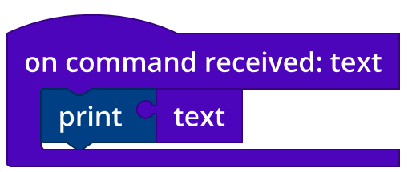

1a. Write functions for rotation to the right, to the left, up, and down. Since voice recognition reacts at a slight delay, it makes sense to turn the camera by an angle transmitted as a parameter each time it is accessed.
Consider the following: How can you prevent the camera from turning too far?

1b. Select appropriate voice commands for the camera control. Add the control functions from sub-task 1a to your program from programming task 4.
Now, control the camera using your voice commands. Ensure the camera does not turn too far.

2. Controlling the camera using the cloud dashboard
You can also control the camera using the IoT dashboard in the fischertechnik cloud.
To do so, after connecting to the IoT server, you must register the TXT as an “MQTT subscriber” using the following function:
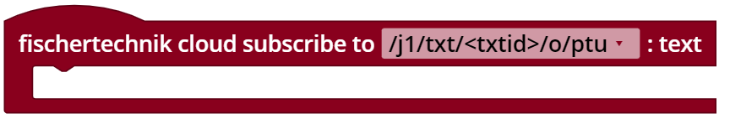
2a. Then, you can read out the command you clicked using the mouse with the following test program:
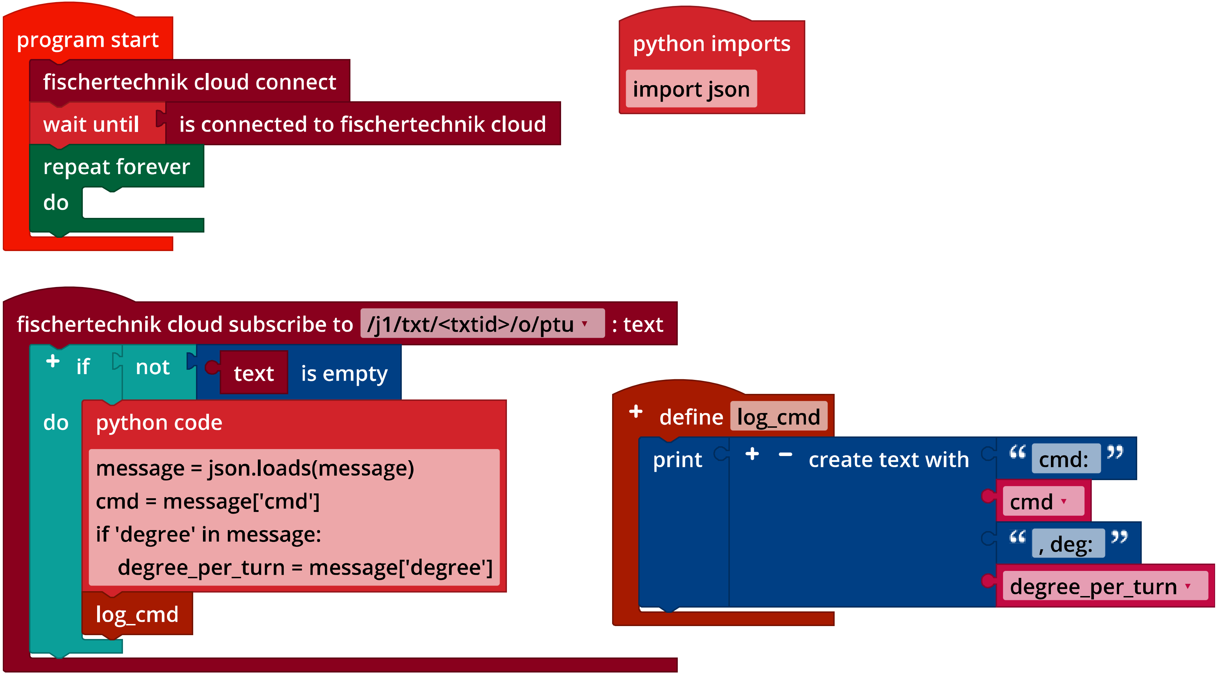
IoT_Test_Dashboard_Control.ft
2b. In addition to the control commands from experimental task 1, there is also a command here designed to move the camera to home position, and one that stops the motors immediately. Add the control commands accordingly.

2c. Now, replace the camera voice control with control via the dashboard.

Annex

Task 3: Alarm system

Required materials
- PC for program development, local or via web interface.
- USB cable or BLE or WiFi connection for transmitting the program to the TXT4.0.
- fischertechnik “Voice Control“ app
- Auxiliary program “IoT_Test_Dashboard_Control.ft”
- Account in the fischertechnik cloud (www.fischertechnik-cloud.com)

