Gears Task 1 – Toothed gear and belt drives

Construction task
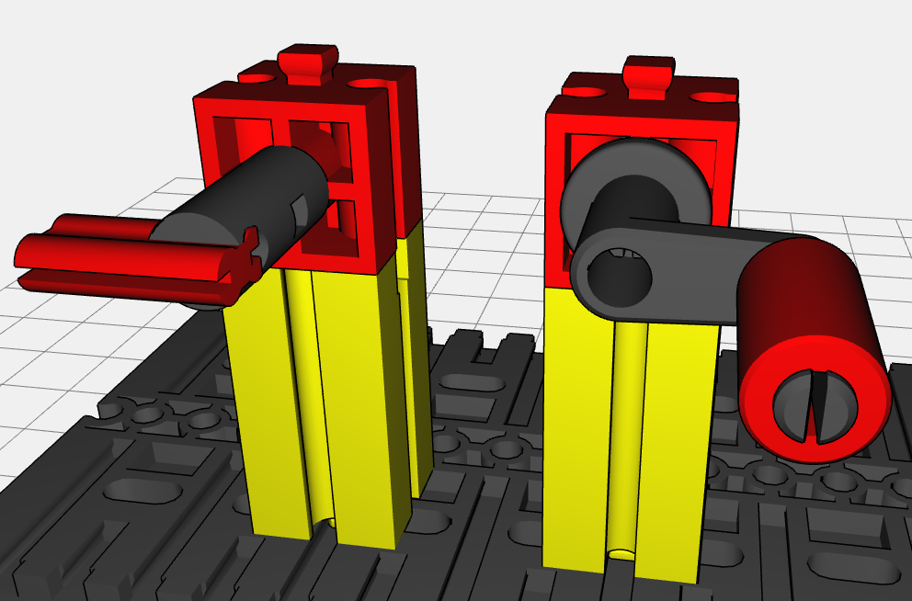
On the image, you can see two axles connected in parallel. One of these is the input (crank) and the other is the output (small “flag”). Add a gearing mechanism to the construction made of toothed gears so that the two axles turn in opposite directions when you turn the crank.

Experimental task
1. How can you add to the gear drive so that the two axles turn in the same direction?
2. Does the movement of the output shaft change if you use another third toothed gear?
3. How can you solve experimental task 1 using a chain or a rubber band instead of the toothed gears?
4. How can you change your rubber band gearing mechanism so that the axles turn in opposite directions from one another?

