Solution sheet

Gears Task 1 – Toothed gear and belt drives
There are different solutions for some of the experimental tasks, each of which have advantages and disadvantages. Students should compare and evaluate these solutions. Calculating the gearing ratios between input and output drive (task 5) is a good and practical application for fractions.

Construction task

Experimental task
1. The direction of rotation can be reversed with an additional toothed gear (or any uneven number of toothed gears), so that the axles turn once again in the same direction.
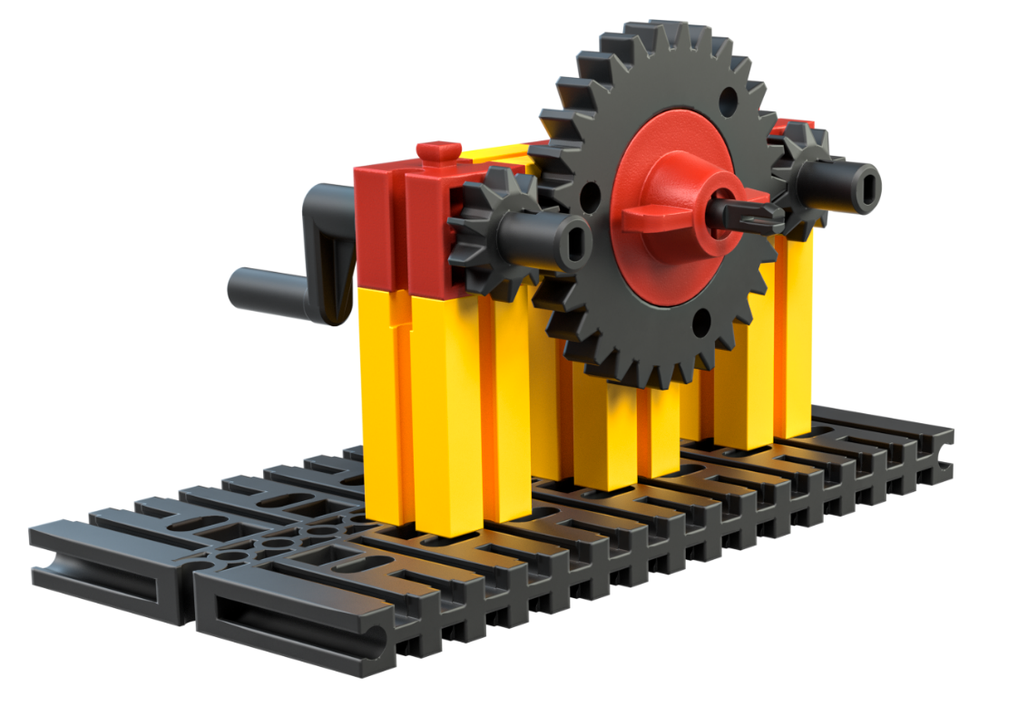
2. The movement of the output axle does not change if the Z30 is replaced with another toothed gear.
3. The direction of rotation remains the same with a belt drive and chain drive.
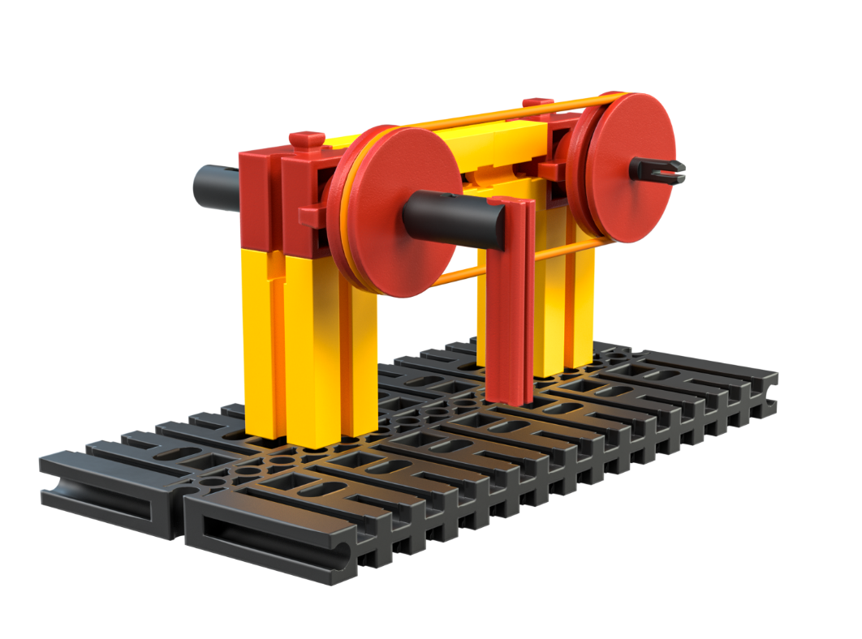
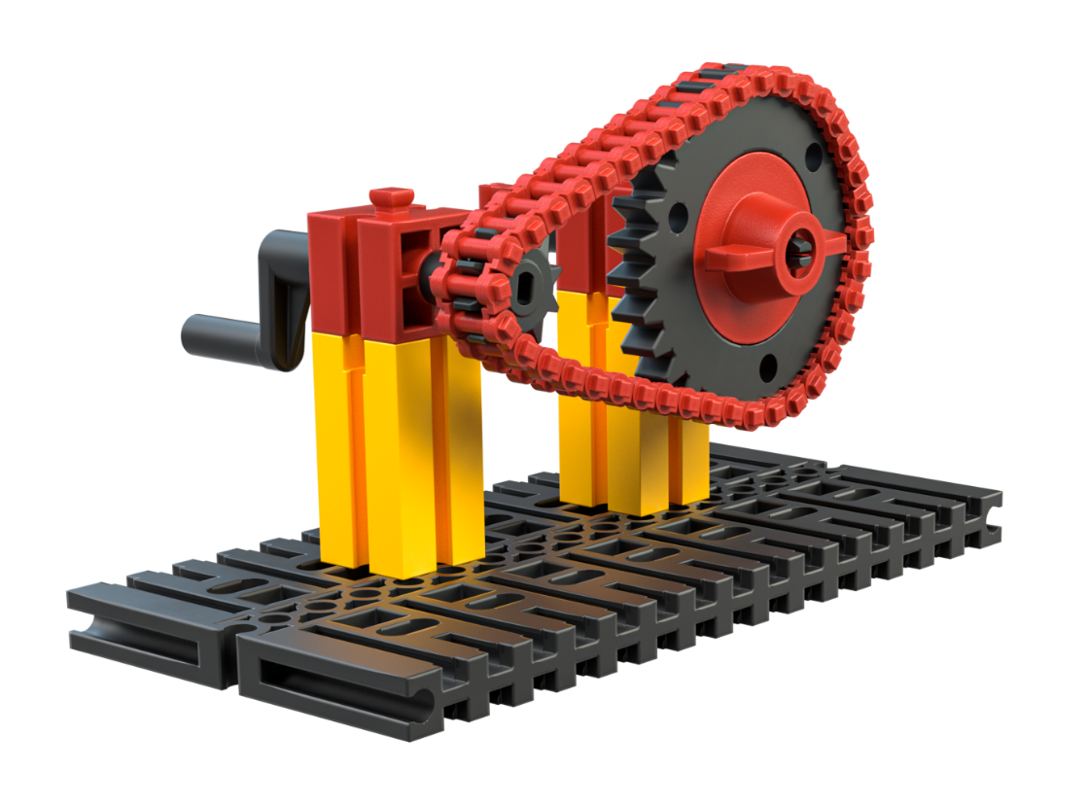
4. The direction of rotation can be reversed by crossing the belt drive (rubber band).
