Gears Task 2 – Cone gear wheel and crown wheel gear

Construction task
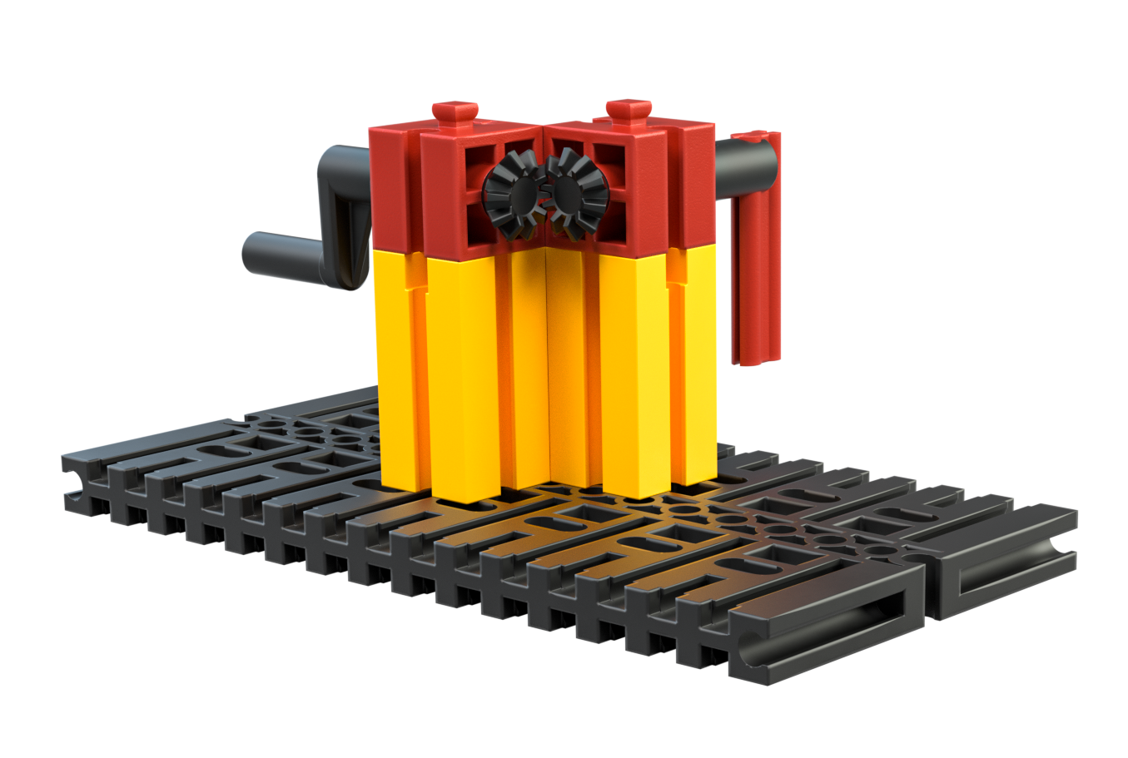
Fig. 2 Cone gear wheel
Build the gearing mechanism shown in the image. Toothed gears that meet at a right angle (90°) and interlock with one another are called cone gear wheels.

Topic question
Observe the output axle and turn the crank. Which of the axles (input/output) turns faster? Why?

Experimental task
1. Try to build another “90°gearing mechanism” using the gear components from the set without cone gears wheels.
2. Describe your construction. Observe the output axle and turn the crank. Which of the axles (input/output) turns faster? Why?

