Solution sheet

Gears Task 2 – Cone gear wheel and crown wheel gear
There are different solutions for some of the experimental tasks, each of which have advantages and disadvantages. Students should compare and evaluate these solutions. Calculating the gearing ratios between input and output drive is a good and practical application for fractions.

Topic question
Both axles turn at the same speed, since the number of teeth on both cone gear wheels (10) is identical (no gearing ratio).

Experimental task
1. Instead of the cone gear wheels, you can build a crown wheel gear with a Z40 and, for example, a Z20.
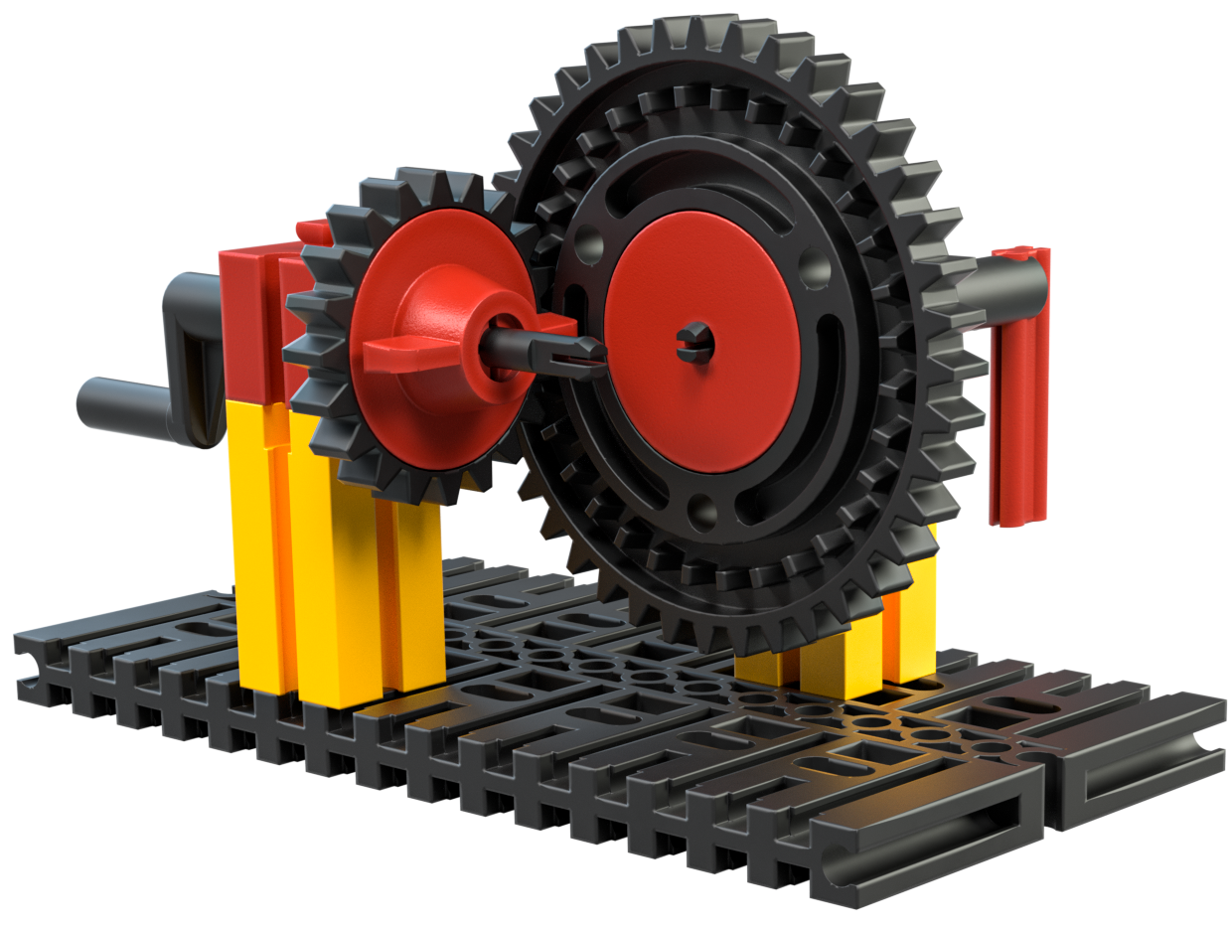
The following rack and pinion gear is an alternative construction. Here as well, the rotational movement is transformed by 90° when you understand the second crank as the output shaft. Disadvantage of the gearing mechanism: The length of the rack is limited.
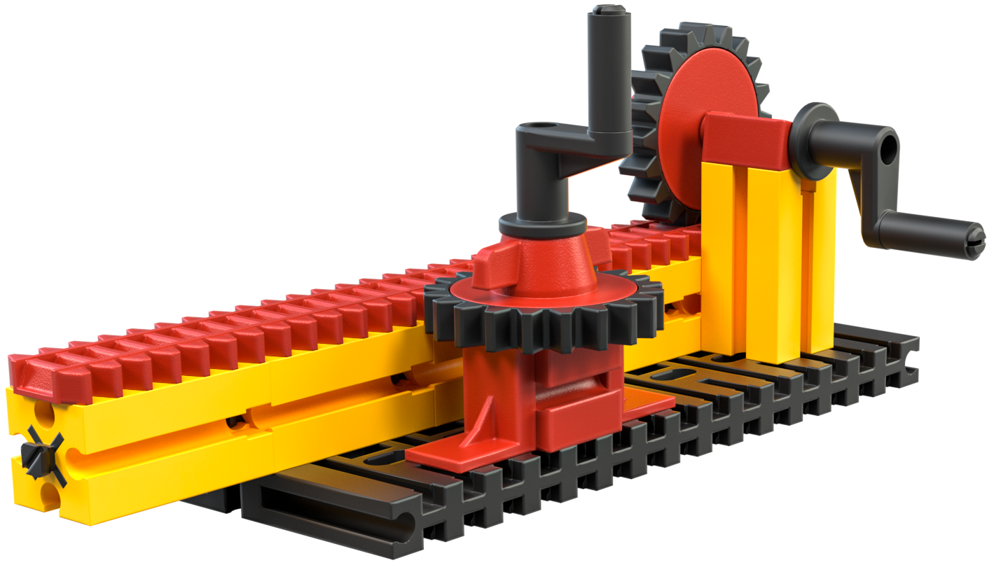
2. When building the crown wheel gear, the gearing ratio is 20:32, gearing down (or, abbreviated: 5:8). This means that the Z20 turns eight times, while the Z40 makes five revolutions. This can very easily be checked via experiments using a coloured sticker on the toothed gears and counting during cranking.
In a rack and pinion gear, the input and output axles turn at the same speed.

