Solution sheet

Gears Task 3 – Transmission gearing (I)
There are different solutions for some of the experimental tasks, each of which have advantages and disadvantages. Students should compare and evaluate these solutions. Calculating the gearing ratios between input and output drive is a good and practical application for fractions.

Construction task
The construction task can be solved by a gearing ratio of a Z20 to a Z10, or by a Z40 to a Z20.

Topic question
The difference in speed is expressed in the ratio between the teeth on the two toothed gears.

Experimental task
1. By dividing the number of teeth of the toothed gears involved in the transmission: The number of teeth on the toothed gear on the input shaft, divided by the number of teeth of the toothed gear on the output shaft equals the factor by which the output axle is accelerated or slowed in contrast to the input axle.
2. This works, for instance, with a hub 60 on the input axle and a hub on the output axle, connected via a rubber band.
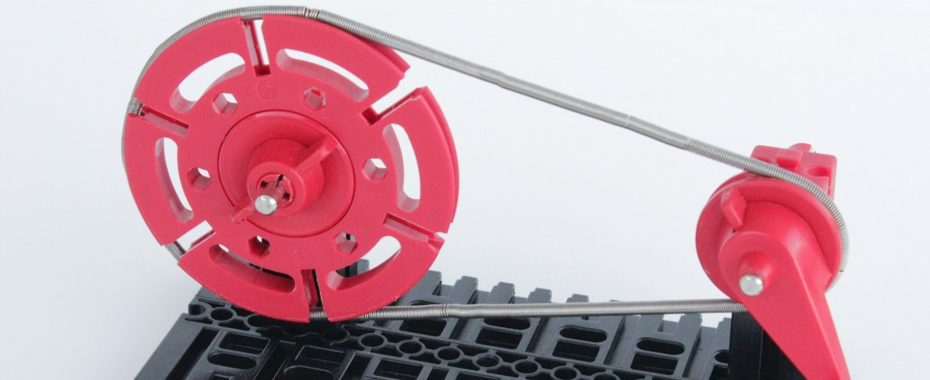
The same can be accomplished with a chain drive using a Z20 (input) on a Z10 (output) or a Z40 on a Z20.

