Solution sheet

Gears Task 4 – Transmission gearing (II)
There are different solutions for some of the experimental tasks, each of which have advantages and disadvantages. Students should compare and evaluate these solutions. Calculating the gearing ratios between input and output drive is a good and practical application for fractions.

Construction task
The construction task can be solved by a gearing ratio of a Z10 to a Z20, or by a Z20 to a Z40 (simply exchange the input and output axles by removing and re-inserting the crank).
The expansion of the gearing mechanism from task 3 could, for instance, look like the following:
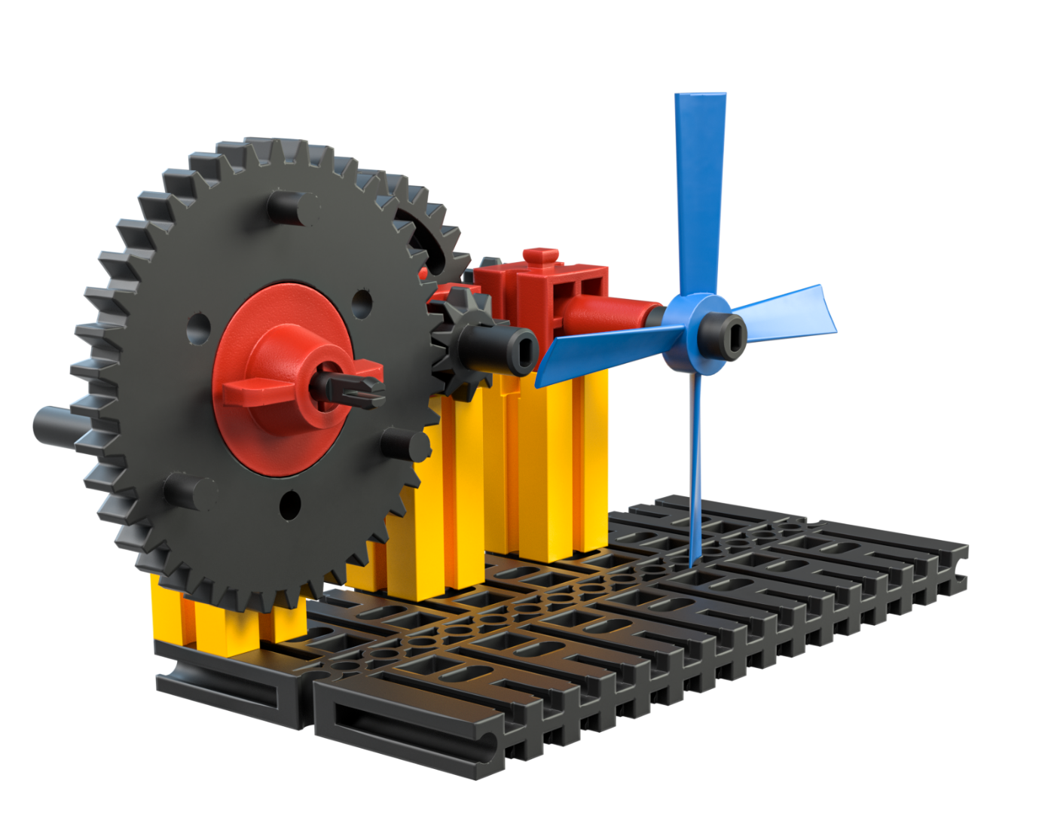
A chain drive can also be used.
You obtain the gearing ratio for the entire gear mechanism by multiplying each additional gearing ratio with the previous one. The gearing ratio is then calculated from the number of teeth on the toothed gears as follows: 40:10 x 30:10 = 4:1 x 3:1 = 12:1.

Experimental task
1. The construction of the 12:1 gearing mechanism can be expanded by additional gearing ratios (such as another 20:10 gearing ratio). A chain or even belt drive can be added here as well.
2. With an additional 2:1 gearing ratio, the output axle would turn 24 times as fast as the input axle.

