Gears Task 5 – Transmission gearing (III)

Construction task
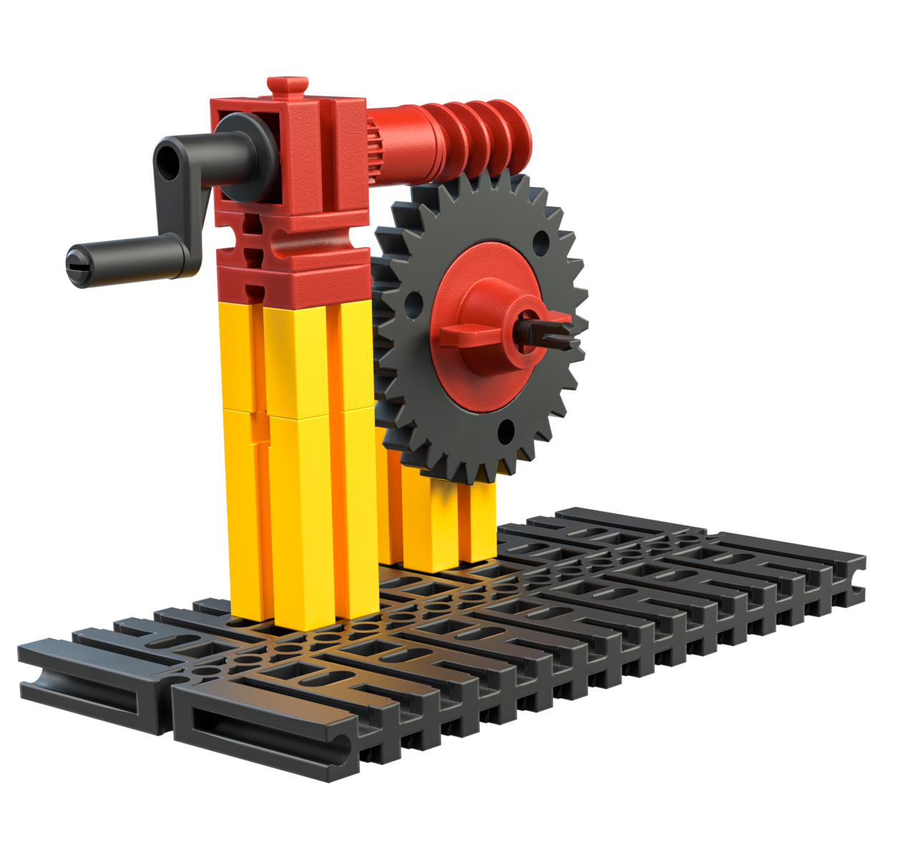
Fig. 3 Worm gears
Build the worm gear shown in figure 3. This unique kind of gearing mechanism is “self-locking”, which means that the output axle can only be moved by setting the input axle (the worm gear) in motion using the crank.

Experimental task
1. Add additional gear elements to the gearing mechanism so that the output axle turns as slowly as possible.
2. Determine the speed of the output axle in relation to the input axle – by counting the rotations, or, even better, through calculating?

