Optics model 1 - Total reflection

Topic
Optical laws of reflection

Construction task

Build a protractor with slot aperture
Use parts from the classroom set to build the “Protractor with slot aperture” - use the mirror for this task
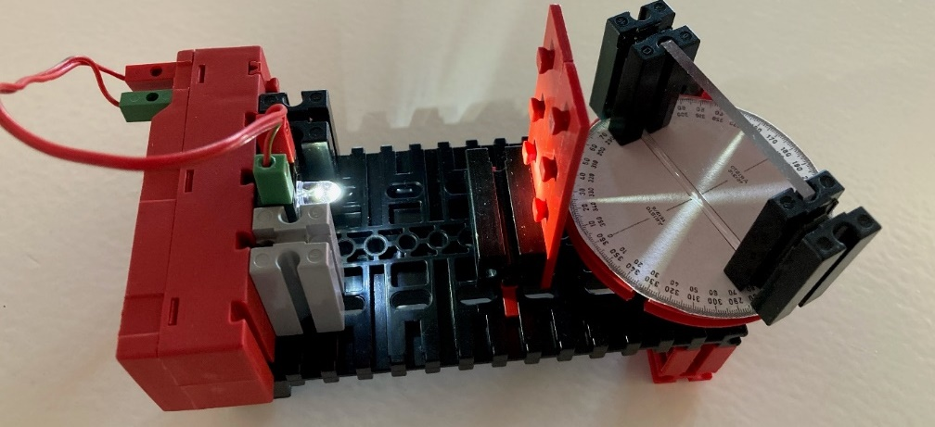
Figure 1 – Protractor with slot aperture

Topic task:

Measure angle of incidence and angle of reflection
Switch the light source on and align the slot aperture so that the light beam hits directly in the centre of the angular scale. Turn the mirror construction so that the light beam is deflected at an angle. What do you observe?

Test out the following angles of incidence:
Angle of incidence α | Angle of reflection α ‘
45°
60°
0°

The angle of incidence α is the angle between the incoming light beam on the perpendicular reflecting surface – the angle of reflection α‘ is that of the reflecting beam on the perpendicular.

