Solutions optics model 1 – Total reflection

Example solution for construction task

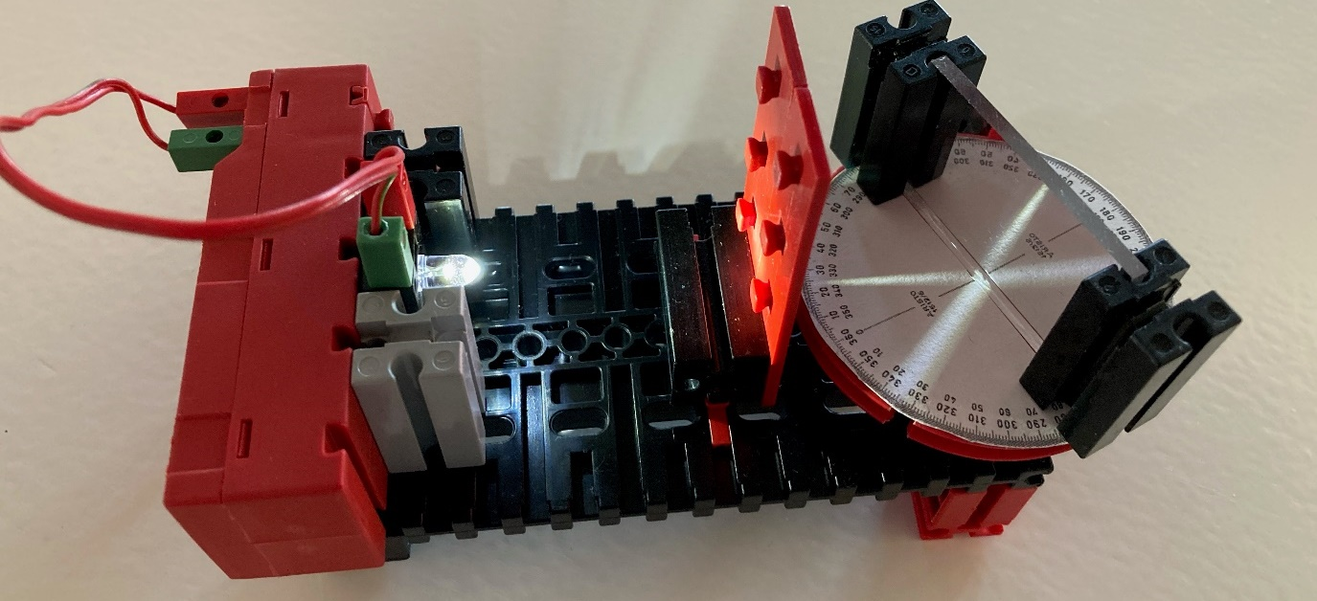
Figure 1 – Protractor with slot aperture

Angle measurement solution: “Angle of incidence equals angle of reflection”
The law of reflection states that the measurement of the angle α to the axis of incidence is equal to the angle of reflection α‘ to the axis of incidence. This is easy to see in this experiment.
Other principles of the law: The light path can be reversed. If the light path for the incident beam is the same as for the reflected beam, it will be reflected within itself.
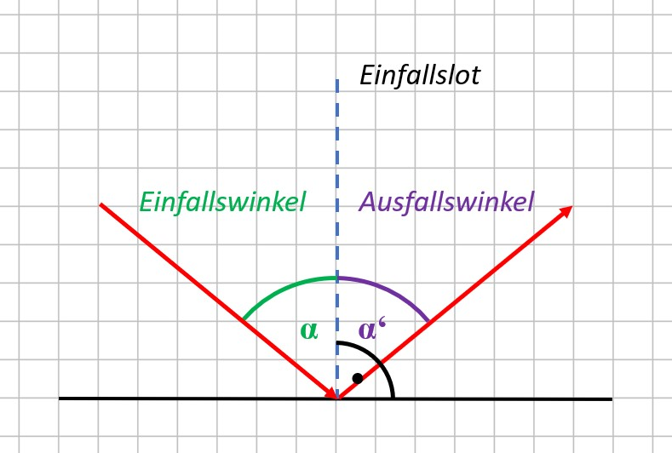
Einfallslot | Axis of incidence
Einfallswinkel | Angle of incidence
Ausfallswinkel | Angle of reflection

Figure 2 - Total reflection

Example solution

Solutions for α = 45°, 60° and 0°
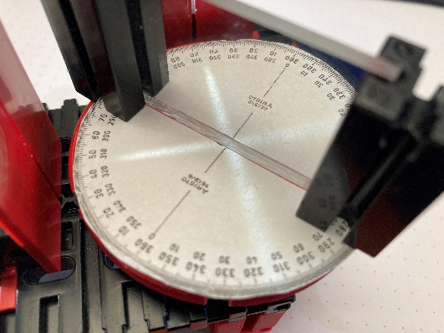
α
α‘
Figure 3 – Solution for α = α‘ = 45°
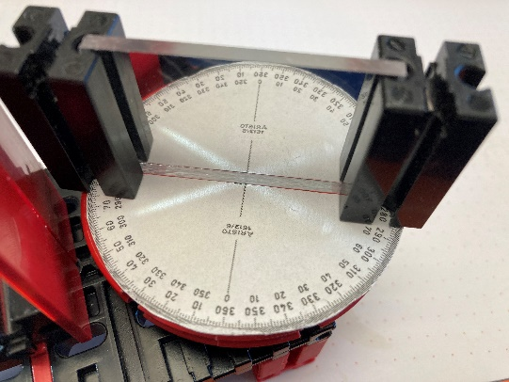
α
α‘
Figure 4 – Solution for α = α‘ = 60°
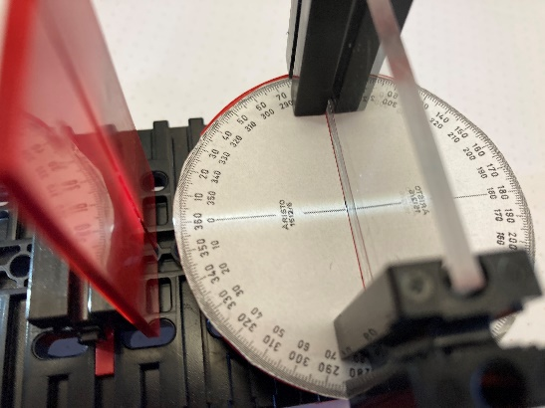
Figure 5 – Solution for α = α‘ = 0

For the angle α to the axis of incidence, we can see that the angle of incidence on the axis of incidence is 0°, and the light beam is reflected within itself.

