Optics model 1 – Diffuse reflection

Topic
Optical laws of reflection

Construction task

Build a protractor with slot aperture
Use parts from the classroom set to build the “Protractor with slot aperture” - hold a white piece of paper up in front of the mirror.

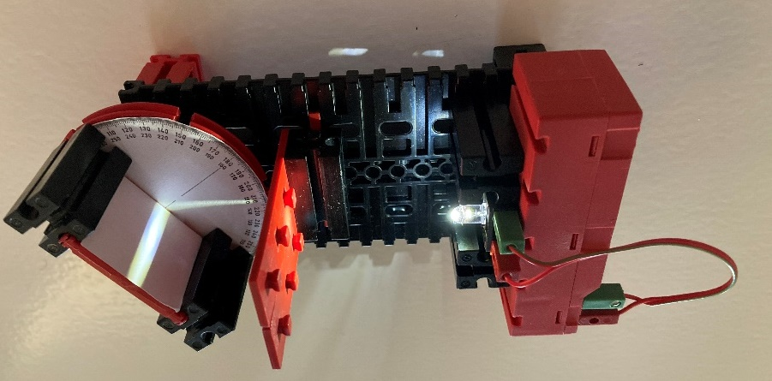

Topic task:

Measure angle of incidence and angle of reflection
Switch the light source on and align the slot aperture so that the light beam hits directly in the centre of the angular scale. Turn the mirror holder so that the light beam hits the white surface at an angle. What do you observe? How can you explain this effect?

