Solutions optics model 3 – Magnifying glass

Example solution for construction task
Build the magnifying glass:

Build the magnifying glass with lighting:
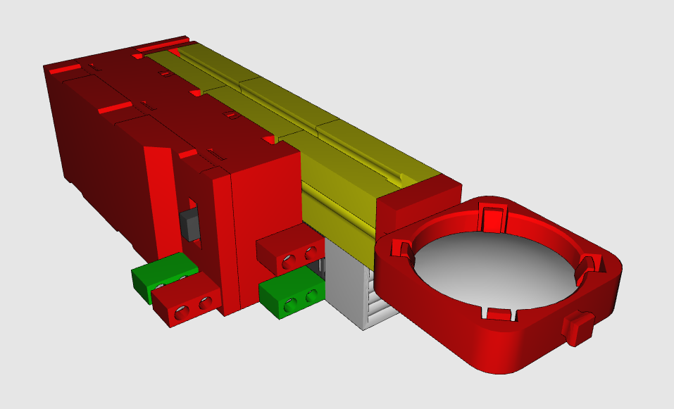

Topic task solution:
If you hold the magnifying glass over a ruler, you can observe how the image in the magnifying glass is magnified. The distances between the millimetre lines on the ruler look greater than they are in reality due to the magnifying glass.
If you hold the magnifying glass closet to the scale, the distances become greater.
If you move the magnifying glass away from the ruler, the distances become smaller.

This means you can use the magnifying glass to change the size of the image you are viewing. How can you make use of this property of magnifying glasses? Some people cannot see small things very well with their eyes. Often, older people have trouble reading small letters in a book or newspaper. In this case, a magnifying glass can be very useful to magnify these things or letters and allow these people to read hem once again.
Researchers also use this effect in microscopes to make minute things visible that would not be able to be seen with the naked eye.
If you look at a wooden board with the magnifying glass, for instance, you can identify individual fibres.

On a computer screen, you can see that each pixel consists of 3 tiny coloured lights. One light is red, one is blue and the third is green. These three colours are used to display every visible colour. Therefore, these kinds of screens are called “RGB monitors”. RGB stands for “red - green - blue”. When all three lights, red, green and blue, are illuminated at the same brightness, this creates “white”. The colour changes depending on how brightly the individual lights are illuminated, because the basic colours mix in different ways.

To experiment with these “light colours” yourself and generate your “own colours”, for instance, you can build a colour wheel and add different basic colours to it to create your own colour mixtures. Try it out!

