Optics model 3 – Smartphone magnifying glass

Construction task

Building the smartphone magnifying glass
Build the model of the smartphone magnifying glass.

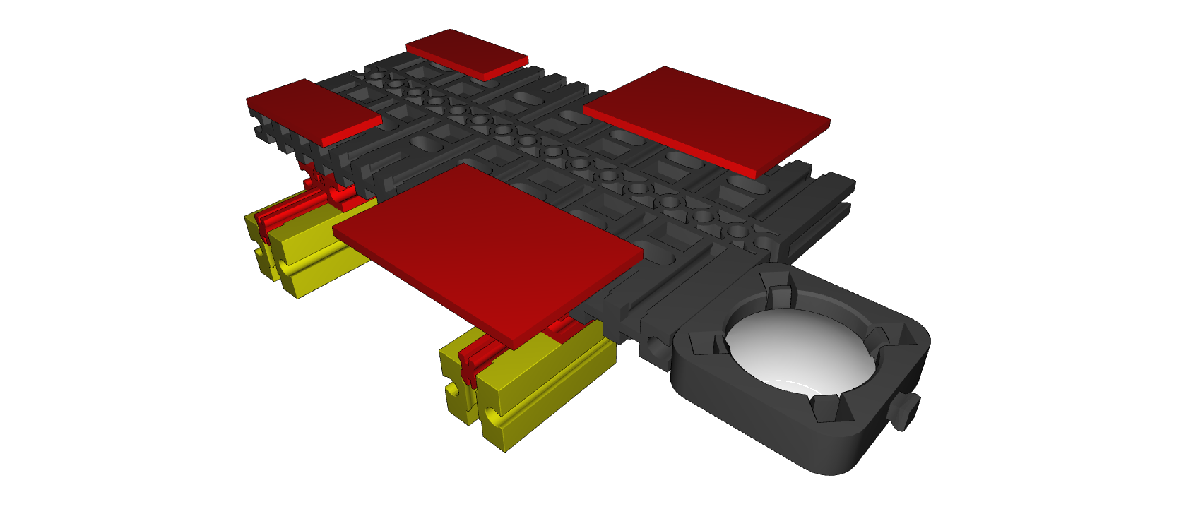

If you use a tablet: build the tablet variant for the lens:

Topic task:
Determine how much your smartphone magnifying glass can enlarge the ruler. To do so, take a picture of the millimetre scale. Now, measure the distance on the display between two millimetre markings. Enlarge the image on the screen. Now, you have the magnification factor for your magnifying glass. Measure once again. What is the greatest magnification factor?

Enter your results here:

Normal magnification: __________mm
Maximum magnification: __________mm

Look at the screen of a computer with the highest magnification. What do you notice? Can you sketch out the structure of the smallest pixels?

