Optics model 4 – Sundial

Topic
Optics – Shadows

Construction task

Building the sundial
Build the model of the sundial

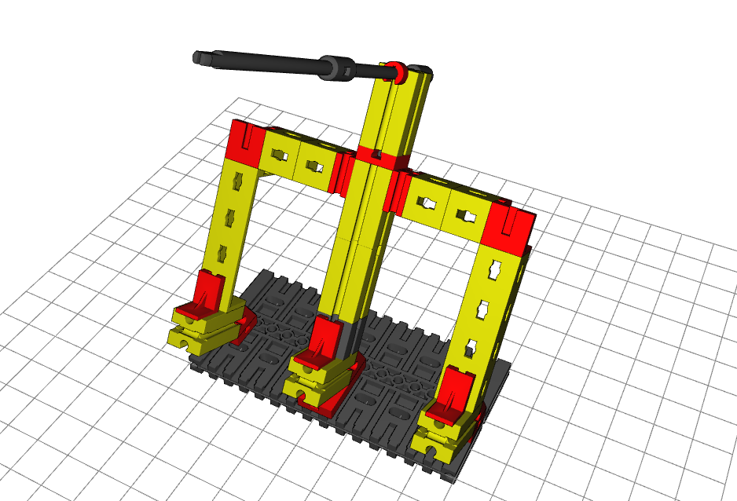

Topic task:
You can complete this experiment over the course of several weeks. Mark the positions of the shadow on your clock face, marking every half hour. Label the markings with the numbers 1 – 3 and note the time. Ensure that the sundial is not moved during the experiment! To ensure this, you can also exactly mark the position of the clock if your model cannot stay permanently in one place during the entire experiment. It is a good idea to use post-it notes, stickers or strips of removable tape (masking tape) as markings.

