Solutions optics model 5 – Shadows

Topic
Optics – Umbra and penumbra

Topic task solution:
When an LED is switched on, a clear shadow will be shown on the projection screen. The area of the shadow is slightly larger than the column that makes the shadow.
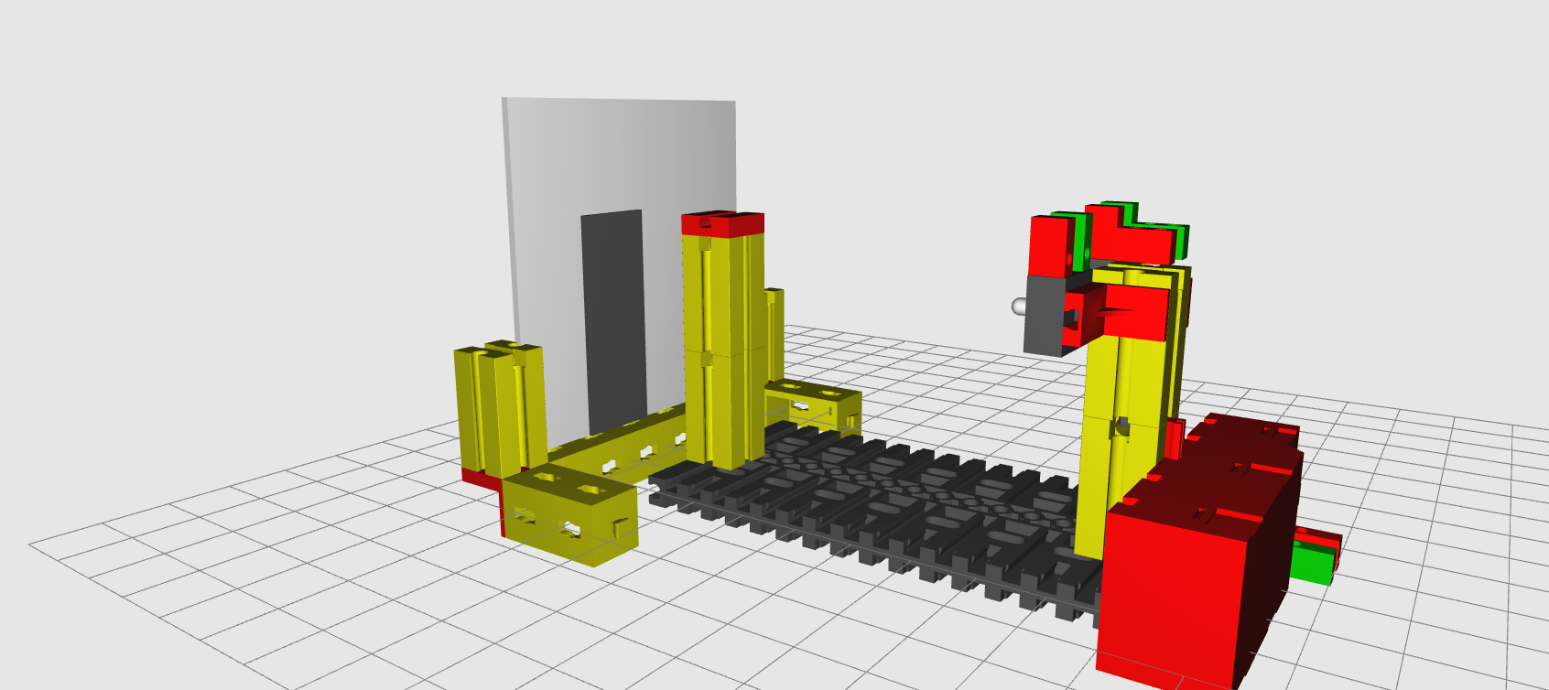
This is because this is a “punctiform” light source. It is clearer if we view our model from above. If we draw a few light beams into the image, we can see why the shadow looks larger than the column.
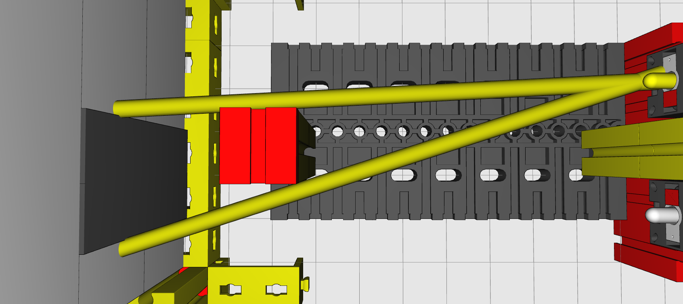
The beams of the punctiform light source do not spread out in parallel, but rather spherically. This is why the shadow becomes larger, the farther the screen is away from the column. With a powerful torch, you can make your shadow as large as a house at night. It’s a great way to scare people, if you want!

If you connect the second LED and move the screen toward the column, at first you will see two shadows. Then the “umbra” will form and become wider and wider until it is as wide as the column – at the point where the screen touches the column.

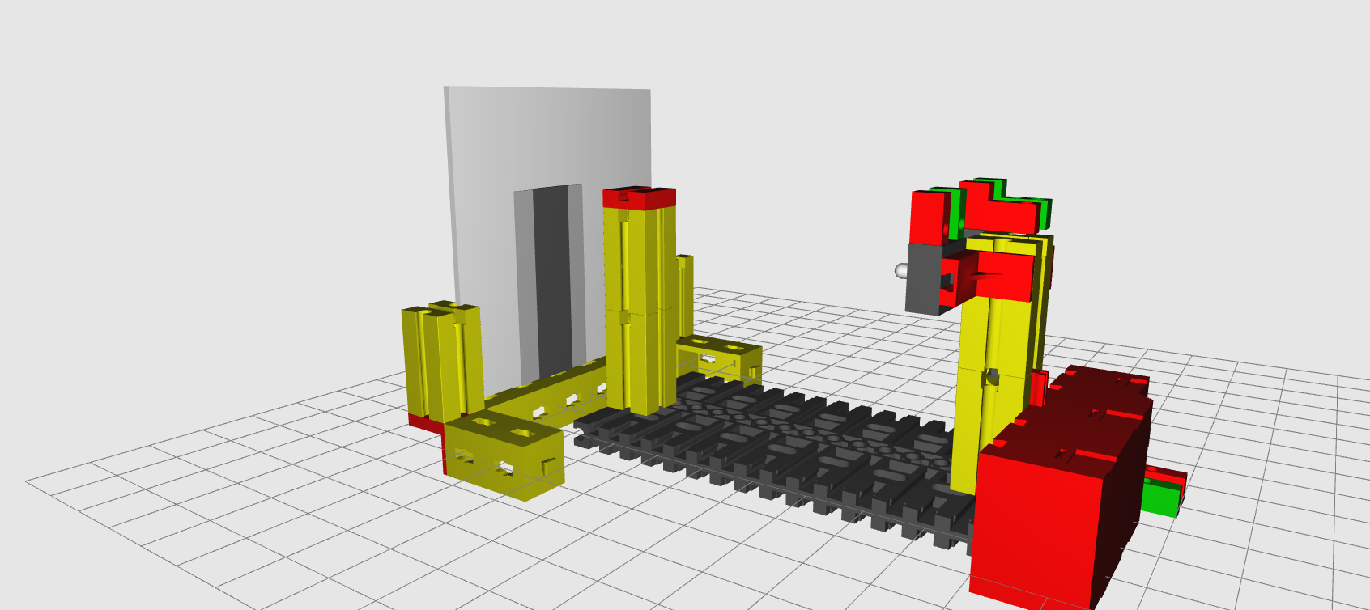

If we look at our model from above once again and draw two beams of one LED yellow and two beams of the other LED red, we will see why this is:

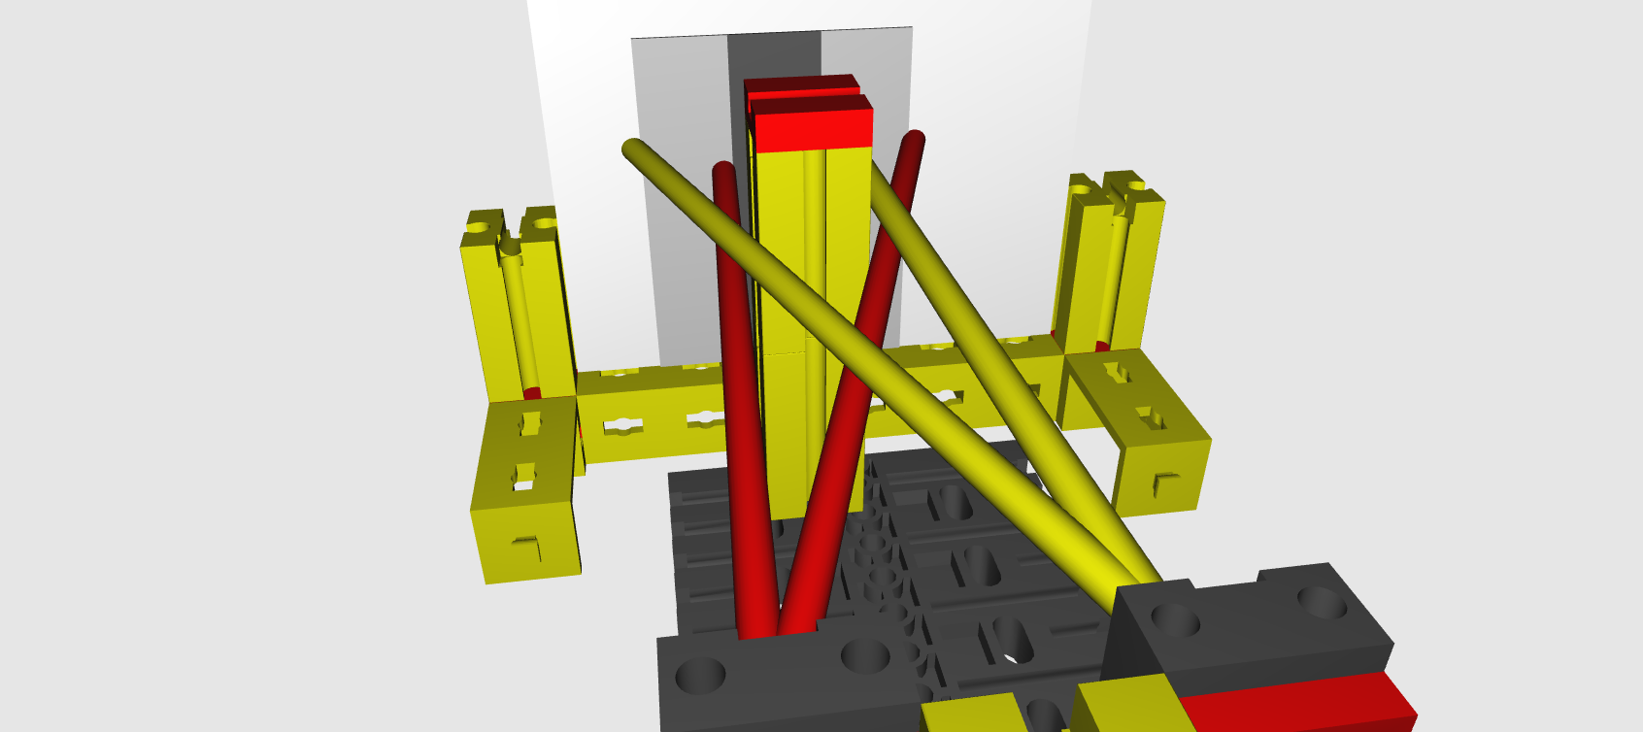

The two shadows the LEDs create overlap. There is an area that is in the light of both LEDs (bright). There is another area that is in the shadow of both LEDs: this is the umbra. This is the darkest area of the shadow. However, there are also areas that are in the shadow of one LED and not the other. These areas are called the penumbra. In reality, there are also light sources that are a surface. This includes windows, for instance. You can imagine these like a surface with an infinite number of small light sources. The shadow of the column - created by these many light sources - behaves in a manner similar to your model. Only the transitions between light and penumbra and umbra are fluid. Test it out!

