Optics model 6 – Colour wheel

Topic
Optics –Colours

Construction task

Building the wheel
Build the “wheel” model

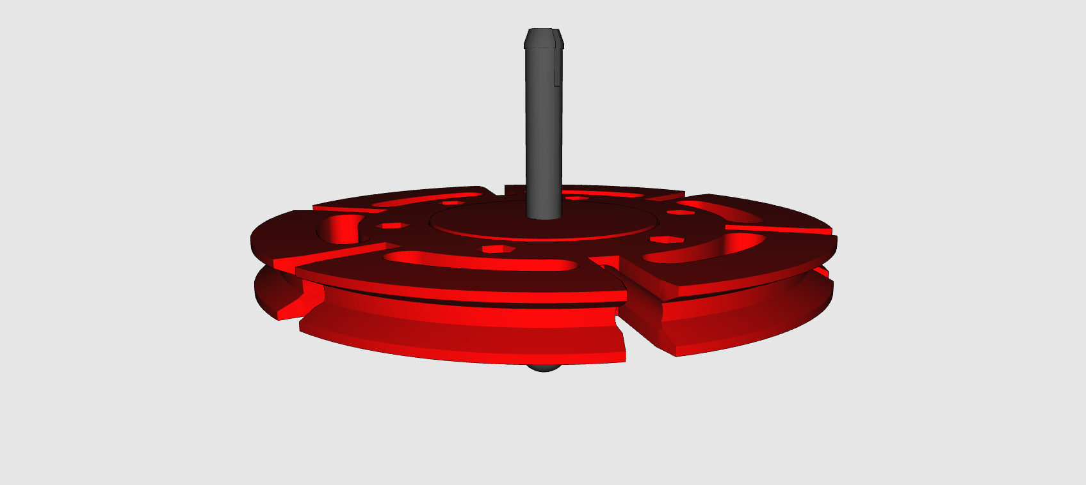

Topic task:
Cut out the different coloured circles from the template and place them on the wheel from the top so that the coloured surfaces are on top. What happens when you turn the wheel very fast? Note which colour you see.

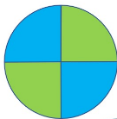
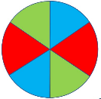
- Circle:
__________
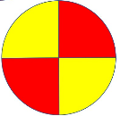

- Circle:
__________
- Circle:
__________

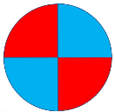
- Circle:
__________

Cut out the other circles and colour them with any colour you want. Try to guess what colour you will see before you start turning the wheel.

