Solutions optics model 7 – Colour wheel

Topic
Optics –Colours

Example solution for construction task

Building the wheel
Build the “wheel” model

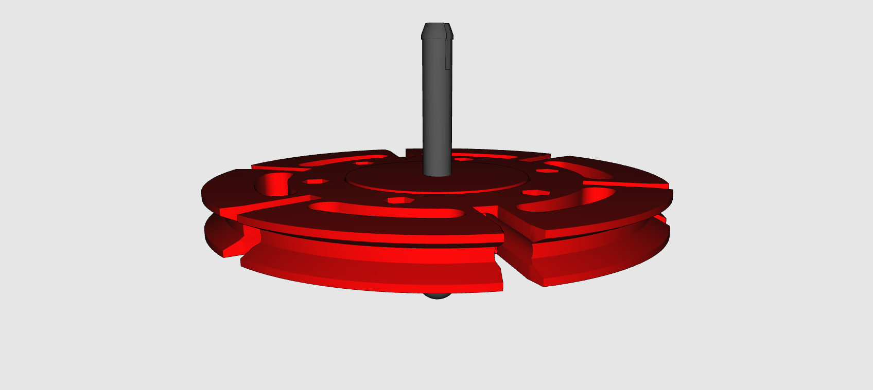

Topic task solution:

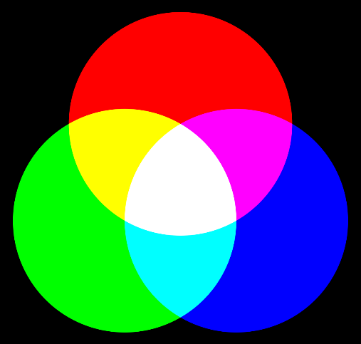
Figure 1: The visible basic colours

White light can be created by mixing the visible basic colours. If you point three headlights, one red, one blue and one green towards a white screen, you can see this very well. A white colour impression will be created in the area where all three headlight cones meet. Now, if you align all of the headlights so that they overlap, the entire circle will appear white. If you now change the brightness of individual headlights, the colour will also change. Depending on the composition of the individual colours, you can generate any visible colour. If you look at the screen of a television with a powerful magnifying glass, you can see that the screen is actually made up of tiny pixels that consist of only red, green and blue.

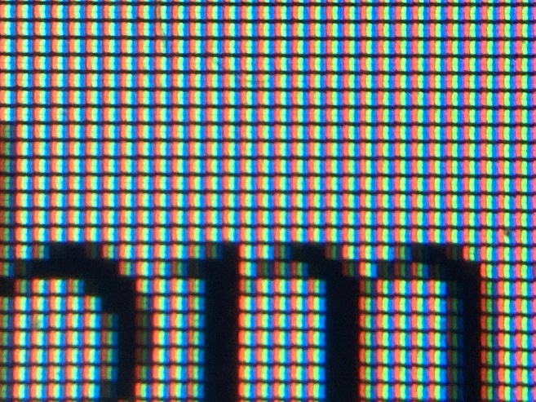
Figure 1: Computer screen (significantly magnified)

In our wheel experiment we have a wheel with these three basic colours. If you turn it very quickly, your brain will no longer be able to differentiate between the colours, and you will see a grey colour. The brighter the ambient light reflected by the wheel, the brighter this grey will appear. In this experiment, you see that mixing colours of light is different from mixing paints: in that case, mixing blue and yellow makes green. In our wheel, you must mix green and red to get yellow. This phenomena is called additive colour mixing. It applies when light beams of different colours mix.

Wheel solutions:

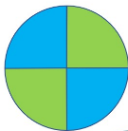
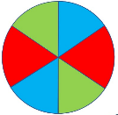
- Circle:
_Grey-white
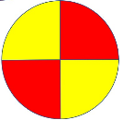

- Circle:
_Orange_
- Circle:
_Yellow_

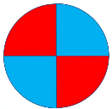
- Circle:
_Purple_

